Please read the instruction carefully before using
This is a unique design to break the traditional single operation, a unique low noise design, soft voice, compact size, light weight, but the shock of a powerful carbon dioxide gas column. Suitable for bars, weddings, and the size of the stage and the performance of the use of easy to install.
Can be used in tandem with the electric and DMX two control mode, the installation can be adjusted in 90 degrees , it has 2 DMX channels, CH1 is gas cluster, CH2 is gas column, which height can reach 8 meters, is very powerful.
1. Two control mode: digital display electric control operation and DMX512 control.
2. The gas column height of the cluster is up to 6-7 meters, which is very powerful.
3. Using high pressure pipe, more convenient for installation of 4 series connection.
4. 90 degrees adjustable.

Parameter
CO2 column jet machine
Voltage | AC110V,60Hz
Power | 70W
Working pressure | 5 Mpa
Consumption rate | 0.35kg/s
Control mode | manual control/DMX
Column height | 6-7 meters
DMX Control channel | 2
Net weight | 5.3kg
Packaging volume (mm) | 450*350*300mm

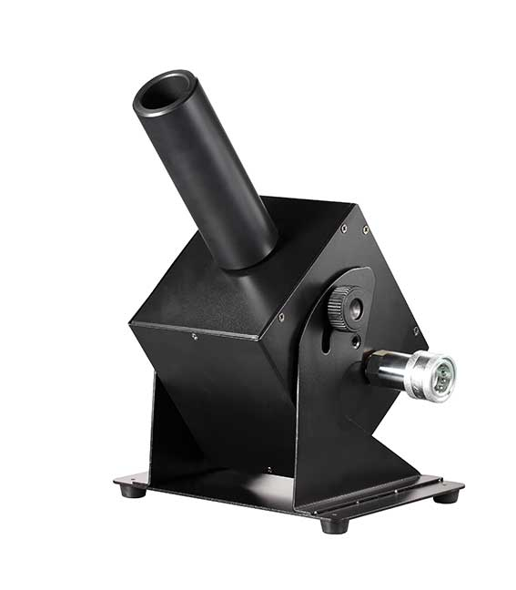 4 series connection

Gas cylinder Connecting pipe
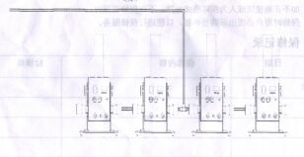

Product warranty card

Product name
Address
Telephone
Zip code
Marketing unit
Sales date
Order No.

Warranty description
1. This product is guaranteed for six months from the date of purchase, please fill out the warranty card correctly.
2. Before use, you must read the instructions carefully and make sure you use it correctly.
3. Failure caused by improper use or human damage, not within the scope of the warranty.
4. The user must show warranty purchase invoices for warranty service.

Guarantee record
Date | Guarantee content | Maintenance staff

CO2 COLUMN

User Manual

