Thank you for having chosen our company’s CO2 machine. For your own safety, please read this user manual carefully before installing the device.
When receiving the machine, open the package and check carefully whether the machine is damaged or the accessories are lost, if any problems, please contact the supplier.

Product parameters:
Power :200W
Voltage: AC220V 50/60Hz
Control: DMX512
DMX Channel: 7 channels
LED color : RGBW 4IN1
Spray height: 6-7meters (depending on humidity)
Weight: 8kg
Size : 300*300*420mm
Pressure rating: up to 1400psi (96bar)

Installs illustration:
- Places the large CO2 column on the corresponding position.
- Connect the CO2 hose to gas bottle.
- Put down the bottle and keep it flat.
- Connect the machine with the gas bottle via the hose, hose one side connect with tank, the other side connect with the machine.
- Turn on the valve of the gas bottle.
- Connect the machine and the console.
- Before disassembling, firstly turn off the bottle valve, let out the gas which remain in the pipe, then turn off the power, lastly separate the connector of the gas bottle.

DMX Instruction:
After connect the DMX512 console. Press switch to DMX,
and the digital display shows A001 DMX address.

DMX has 7 channels, see as following:
Channel 1: CO2 spray (0-255) ON
Channel 2: LED color mixing, (0-225) LED color is mixing.
Channel 3: light-red, ( 0-225)
Channel 4: light - green, ( 0-225)
Channel 5: light- blue, ( 0-225)
Channel 6: light - Amber (0-225)
Channel 7: LED strobe, (CH7+CH3 , CH7+CH4, CH7+CH5 or more)
( 0-225) LED getting faster.

Operation method:
DMX512 signal control: press to the “DMX ” switch, there has 7 channels under the DMX512 signal environment. After connect the DMX512 console, push the first switch will continue for 1 second CO2 column. Push the first switch always, will continue for CO2 column.
Channel 2 to Channels 7 control the LED color and strobe.

Manual control:
After connect the power, press switch to ON, the CO2 gas column up at once.
Digital display: has 4 buttons.
Press switch to DMX,
MENU button: the switch of LED lights
UP/DOWN button : can change color of LED lights
Enter: confirm button
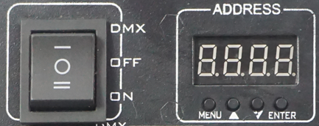
Attention:
- The CO2 column squirt time cannot surpass for long time.
- Two jet time intervals cannot be short in 5 seconds.
- Before connect the power , please be sure each part of the CO2 column is connection already to operation.
- The bottle must put down and keep flat. Or else the gas column can’t go out.
- The trachea connection must be sure link.
- When not use the machine, the nozzle, the steel bottle intake must be envelop, in order to prevent enter other thing.

Malfunction obviates:
Simple malfunction obviate:
- Press down the switch of power console, can’t spray CO2 column, please check connect power or no, the gas bottle have enough barometric or on.
- Press down the switch of power console, the CO2 column effect not well, please check if put down the bottle, or the operation environment is too desiccation.
- If leak a few CO2 from nozzle when operation, please turn off the valve of the gas bottle, and repeat and close the machine, can revel out the trouble.

Special statement:
The high pressure tube, nozzle and steel wire are damageable, not in the range of maintenance.

Warning: CO2 blasts cannot exceed 10 seconds in length for each blast, tow blasts cannot occur withing 5 seconds of each other. Power must be connected last as to ensure safety.

LED CO2 COLUMN MACHINE
User Manual

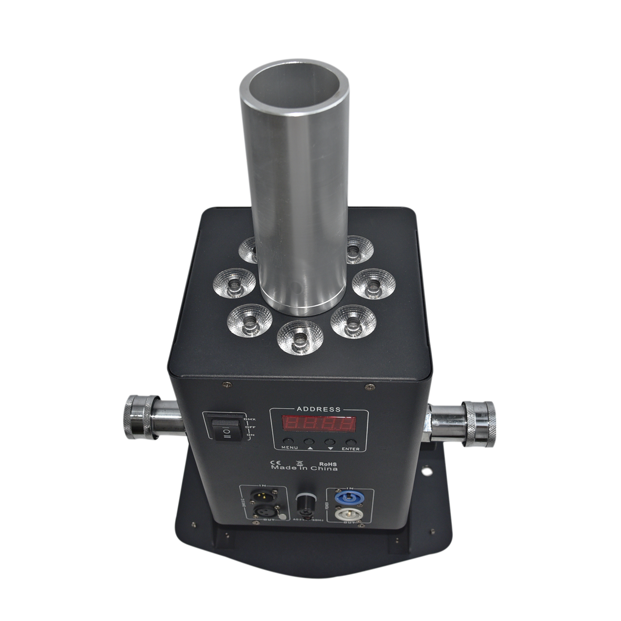 Please read this manual carefully before using

