FEATURE
- Mix Burst CO2 Gun, RGB mixed,can be adjusted according to the different colors,easy to carry on and operate,are wildly popular and preferred among many different entertainment performers and event promoters.
- LED CO2 confetti gun doesn’t need DMX 512 controller and power like other CO2 machines, only need 1 gun + hose + tank + confetti. One CO2 tank is needed per CO2 confetti gun.

- The led CO2 confetti Gun can create strong and high CO2 effects and wonderful confetti effects, which can spray up to 20-25 feet.( 6-7 meters)

- These hand held CO2 confetti guns, could customized by your specific requirement , vary in size and style, giving you plenty of options to choose from. With a hand held CO2 confetti gun , any performance can be transformed into a full-blown production!

- This CO2 confetti gun is the newest and coolest in our special effects product line. Mix Burst CO2 Gun has a color changing tube which changes from red,green,white...seven colors while is shooting out co2 and confetti effect.

SPECIFECATION
Power: 20W
Spray distance:6-7 meters
Control mode : handle ( no power)
Hose length : 5 meters
Weight: 9.5 kg
Size: 77*44.5*31 cm
INSTALL ILLUSTRATION
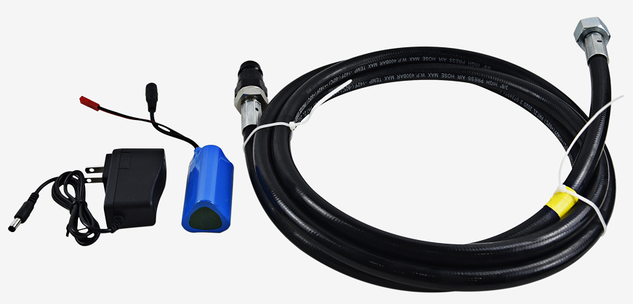

- Connect the CO2 hose to gas bottle , connect the hose to led CO2 confetti gun
- Put the confetti paper or gold or silver confetti into the confetti tank.
- Press the LED button,the led co2 confetti gun can change different color by auto running. Press LED button again,the changeable colors will be stopped.
- Handle the CO2 gun by trigger, the led co2 confetti gun can spray powerful co2 and wonderful confetti.

LEDCO2 GUN BIG

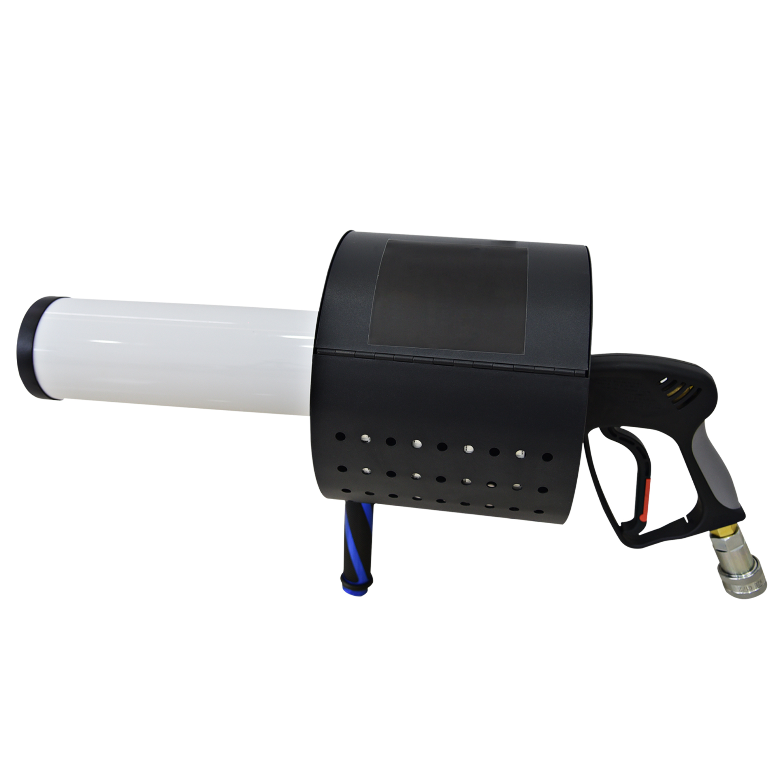

Please read this manual carefully before using

