USER MANUAL Creeper AQ mini Low Fog Generator

★ Please read this manual carefully before operating this product.

W arranty card attached in the manual, please keep it well.

▲SAFETY CONSIDERATIONS

\ Unauthorized repair are prohibited, it may cause serious incident.

\ Make sure power supply in consistent with the rated voltage of the equipment, and the socket must well grounded. Unplug and turn off the machine when not use.

\ Please keep the machine dry, not use in rain or snow. Not use the machine when it is wet or there are fluid leakage from the machine.

\ Not use the machine in high temperature.

\ Installed in well ventilated area, ensure at least 50cmspace around the machine, cover of the nozzle is forbidden.

\ For adult use only, keep it away from children, fire, inflammable and explosive articles.

\ If the machine fails to work, please stop operation and unplug the machine. Check fog fluid bottle, water tank, fuse, power connection etc. carefully, if can't solve the problem, please contact SHOWVEN or your local SHOWVEN partner for advice.

\ Suggest use SHOWVEN original FX-M fog fluid, other fluid may lead to clog or malfunction.

\ In case of eye contact of fog fluid, please wash it with clean water. If fluid is swallowed immediately look for medical advice.

\ Please do NOT adding any other material such as grease, pigment, gas etc to the fluid bottle or water tank.

\ The device shall not be altered and applied to other use purpose.

Foreword

Thanks for choosing SHOWVEN CREEPER AQ mini low fog generator. Please read following manual carefully and completely before operating this product. Operate according to instructions is very important for safety, and can elongate the service life of the machine.

Functional Characteristics

\ Water based, no need of dry ice.

\ Molded enclosure, lighter, durable as well as rustless.

\ Compact yet robust fog output.

\ Multi-optimized air supply system, ensure farther and more uniform fog output.

\ 20 heads atomizers, guarantee thick fog output.

\ Latest rapid heating technology, 1-2min heating up time

\ Patented fog leakage prevention technology, no fog leakage even refill the machine when it is working

\ User friendly LCD control panel

\ 2L fluid tank, support 1h continuous output.

\ Built-in water tank, support external large water tank.

\ Wireless remote control.

▲Technical Specifications

\ Model Creeper AQ mini

\ Dimension 460×300×324mm

\ Voltage AC200-240V, 50-60Hz AC100-120V, 50-60Hz

\ Work Power 3000w

\ Heat-up Time Appr. 1-2min

\ Fluid Tank Capacity 2L

\ Water Tank Capacity 6.5L

\ DMX-512 YES

\ Remote control YES

\ Output Adjustable 1-100

\ Max. Fog Output 10,000 cuft/min

\ Max. Coverage Appr.200 ㎡

\ Max. Fluid Consumption. Appr.32ml/min

\ Max. Water Consumption Appr.250ml/min

\ Continuous Output YES

\ Fully loaded Output Time 70+ min

\ Consumable FX-M Fog Fluid, Water

\ Net Weight 15KG

\ Gross Weight 19KG

Product Overview

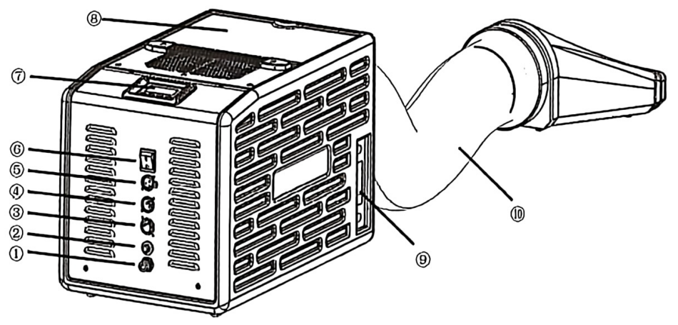

1. External water tank connection port(φ8 quick connector)

2. Fuse

3. Power Socket

-2 -

4.3-Pin DMX IN

5. 3-Pin DMX OUT

6. Power ON/OFF

7. LCD Control Panel

8. Water Filling Port, Fluid Tank

9. Liquidometer

10. Fog output pipe

Operation Panel

1. LED display area

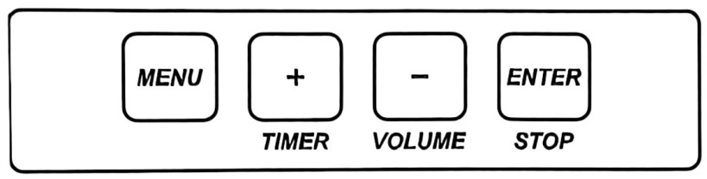

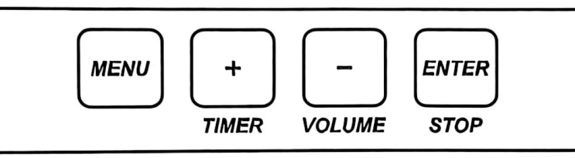

MENU: switch through setup menu;

+: Parameter up; multiplex“TIMER”(smoke output time)

-: Parameters down; multiplex“VOLUME”(smoke output start)

ENTER: confirm and save parameters (screen will blink once parameter saved); multiplex “STOP”.

NOTE: Screen will switch to main interface automatically if not press any button in long time.

▴Interface

1. Main Interface

DMX: 1 FAN: 20

T: 100% FOG: 80%

First Line: DMX address and Fan Speed,“:”blinks when there is DMX in signal.

Second Line: Shows machine core temperature and Fog Volume. The machine ready for operate when temperature value close to 100.

2. Error information:

|  |  |
| --- | --- |
| Error information | Explanation |
| E2 Temp. Sensor | Temp. Sensor Malfunction |
| E3 Water Sensor | Low water level of Inner Water Tank, system is  pumping water to inner water tank or liquid  level sensor malfunction. |
| E5 Temp. Over | Circuit board malfunction |
| E6 Heat Fail | Heater broken or circuit board malfunction. |
| Error information | Explanation |

3. Setting Menu:

Press“MENU”switch through setup menu.

-3-

|  |  |  |
| --- | --- | --- |
| Items | Value | Explanation |
| DMX Address | 1~512 | DMX address setup |
| Interval Set | 5-600s | Set fog output interval |
| Duration Set | 5-600s | Set fog output duration |
| Fog Volume Output | 1-100% | Fog output volume setup |
| Fan Speed | 1-100% | Fan speed setup |
| Wireless Set | ON/OFF | Wireless function set |
| 语言(Language) | 中文/English | Language switch |
| Auto Pump | ON/OFF | When it is ON, machine will pump water from  exterior water tank to inner tank, and stops  when the inner tank filled up. Please turn it to  OFF when not use exterior water tank. |

Operation

1. Check the machine and accessories, ensure it is in good status. Place the machine on a flat surface, tilting may result in inaccurate water level alarm.

2. Fill the liquid tank with FX-M Pro me dium fog fluid. Please use original fog fluid from SHOWVEN, Warranty will be void if any other type fog fluid is used.

3. Connect the machine to suitable rated power supply. Please ensure power supply meets the requirement. Always connect the machine to a protected circuit and ensure it is properly grounded.

4. Turn on the machine, it heat up automatically, and shows“WARMING UP”on LCD screen.

5. Water Tank Filling

Method 1:

Open the lid of“water filling port”, fill the water tank with pure water, please pay attention to the water level show on liquidometer, stop filling when it is reached the black line. Or until the water shortage alarm on LCD screen disappear.

Method 2:

Useφ8 tubes connect with quick connector on machine, and the other end put into exterior tank, press MENU enter setup interface, find the“Auto Pump”and switch it in to ON status,press ENTER key to save the change. Machine will filling the inner water tank automatically,just keep the water in exterior tank is enough for the show. When not use exterior tank, please do set the“Auto Pump”to OFF status.

6. Once the machine has reached operating temperature, temp., fog output and fan speed will show on the screen, please adjustable it accordingly.

7. Press“+”to start making fog, press“ENTER”to stop.

8. To turn off the machine, please POWER OFF and unplug the power cable.

9. For transportation or not use for a long time, please remove the fog output pipe. Drain the remaining water from fog output nozzle.

DMX Channel

2 channel mode

|  |  |
| --- | --- |
| Channel | Function |
| First Channel(CH1) | Fog output: DMX VALUE 6-255, fog output from 1-100. As volume  increase, the denser the fog, the longer for dissipate. |
| Second Channel(CH2) | Fan speed: DMX VALUE 6-255, fan speed from 1-100. As volume  decrease, the better the fog stick to the ground but spread slower. |

Wireless Control

Wireless control is used to remote control the machine. Before use the wireless function please make sure machine was ready, wireless status was ON, and no DMX cable connection.

Remote controller:

1. Fog output START

2. Fog output STOP

Remote control is optional configuration.

When wireless controller is not working properly, please switch to the Wireless Control menu,set it into ON status, and press ENTER key to save the change.

When machine on Wireless Control interface, operator can match the CREEPER AQ mini with remote controller by pressing any key on remote controller for 1s, the machine screen flash once means match was finished.

Product Package

1. Creeper AQ mini Low Fog Generator x 1unit

2. Power Cable x 1 piece

3. Fog Vent and Head x 1 piece

4. 1mφ8 PU pipe x 1 piece

▲Possible reason for fluid spill and block of atomizer

For healthy and best status of machine, please do use SHOWVEN original fog fluid.

A. Fluid spill: heat can't effectively transmit to fog fluid, leads to insufficient atomization of the fog fluid in the heating pipe.

Possible reason 1: Use low quality fog fluid. The impurities in low quality fog fluid easily adhere to the pipe inner wall, which blocks temp. transmission, leads to insufficient atomization.

Possible reason 2: Use inappropriate fog fluid. For different types of fog fluid, the atomization temperature is different.

B. Heating aluminum pipe clog: early symptom for heating aluminum pipe clog is fog fluid spill caused by insufficient atomization. Use other brand fluid or not make regular maintenance for a long time will definitely leads to pipe clog.

C. Solution for above problem: Use SHOWVEN original fog fluid. Make regular maintenance (every 1-2 month). Use 35% vinegar with 65% distilled water to wash the pump and pipe system by running the machine 10-15 times.

Warranty Instructions

▲Sincere thanks for your choosing our products, you will receive quality service from us

▲The product warranty period is one year. If there are any quality problems within 7days after shipping out from our factory, we can exchange a brand new same model machine for you

▲We will offer free of charge maintenance service for machines which with hardware malfunction (except for the instrument damage caused by human factors) in warranty period. Please don't repair machine without factory permission

★Below situations NOT included in warranty service:

1. Damage caused by improper transportation, usage, management, and maintenance, or damage caused by human factors;

2. Disassemble, modify or repair products without permission;

3. Damage caused by external reasons(lightning strike, power supply etc.)

4. Damage caused by improper installation or use;

For product damage not included in warranty range, we can provide paid service.

★Invoice and warranty card are necessary when applying for maintenance service from SHOWVEN.

Warranty Card

|  |  |  |  |
| --- | --- | --- | --- |
| Product Name: |  | Serial No. |  |
| Purchase Date: |  | | |
| Tel: |  | | |
| Address: |  | | |
| Info. feedback  about the  problem: |  | | |
| Actual problem: |  | | |
| Maintenance  detail: |  | | |
| Service Engineer: |  | Service Date: |  |

- 6-