**Model No. - 11016010**

**PIXEL STRIP RGB**

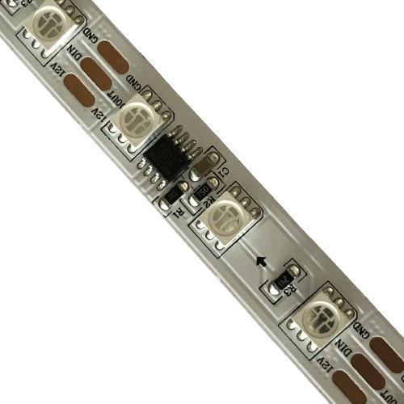

**Feature**

Brightness > 2100mcd, 5050 RGB led lamp with copper bracket and gold wire

2oz pure copper PCB board with10mm width

Double membrane covering the FPCB board for better protection

Standard SPI protocol - WS2811 IC chipset

Cutting unit - 50mm / every 3 led

DC12V, 12W per meter

LED Quantity: 60 pcs per meter

Controller system: Art-Net or off-line or on-line led controller

**Parameter**

|  |  |
| --- | --- |
| Part No | RL-STR-WS2811-5050RGB-60-12V |
| LED Chip | Sanan 5050 RGB |
| Voltage | DC12V |
| Power | 12W/M |
| PCB quality | 2OZ, Double layer, 25um50um copper |
| LEDs Qty | 60 LEDs per meter |
| Luminance (mcd) | 2100MCD per led |
| IC chip | WS2811 |
| Plug | 3 pin female and male connectors |
| Waterproof Grade | lP20 |
| PCB width | 10MM |

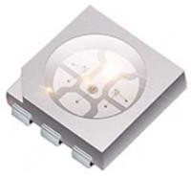

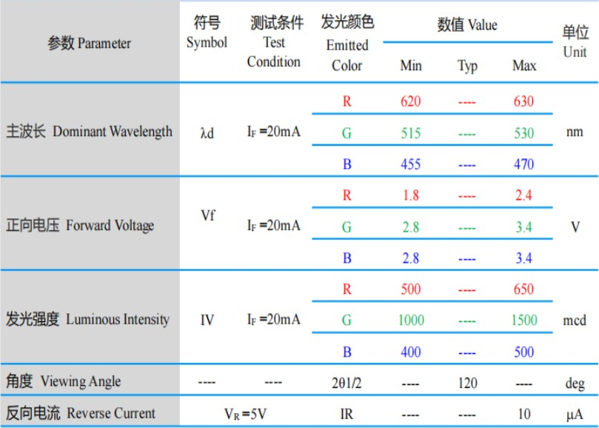

Wavelength Group(IP=20mA, Ta=25C)

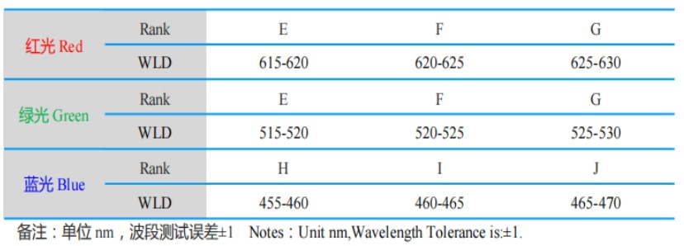

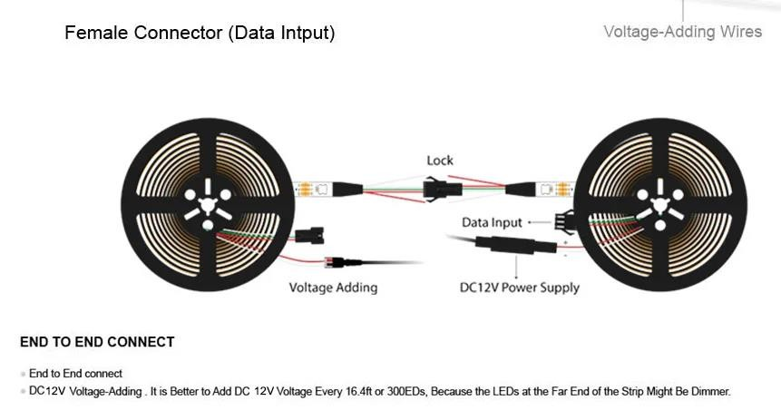There is 3 Pin JST SM female/male connector on both end for signal input/output and power inputs at ends.

Color definition:

12V -- RED, DI -- GREEN, GND -- WHITE

Input: Female Connector output: male Connector

Wiring Chart

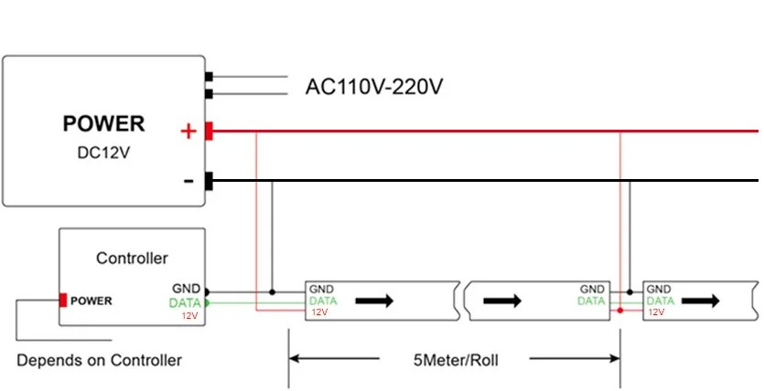

**RED**

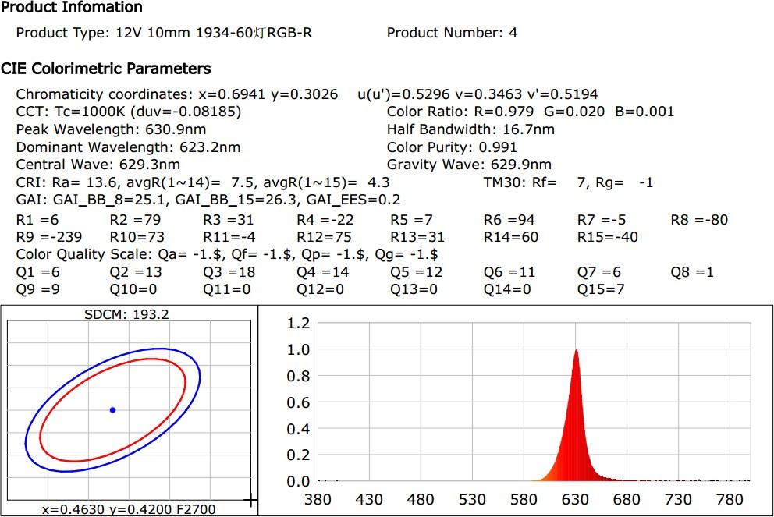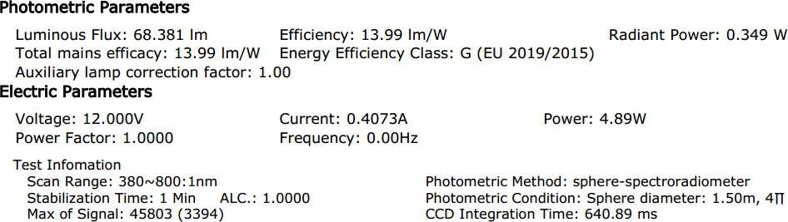

**GREEN**

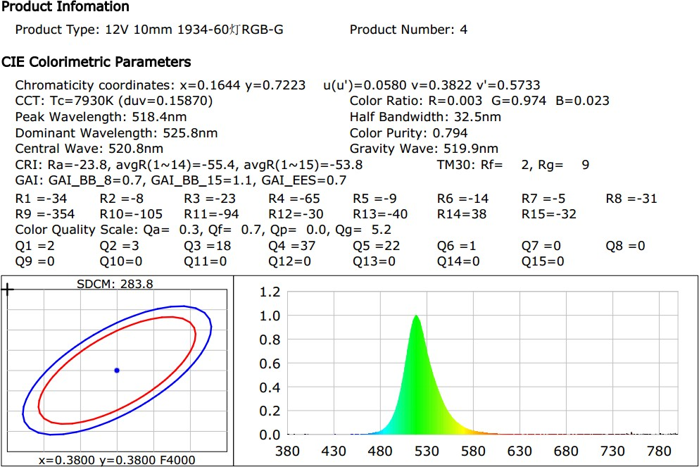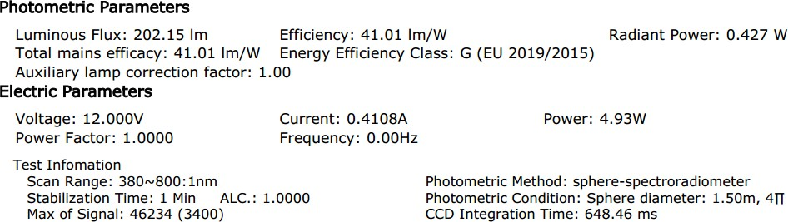

**BLUE**

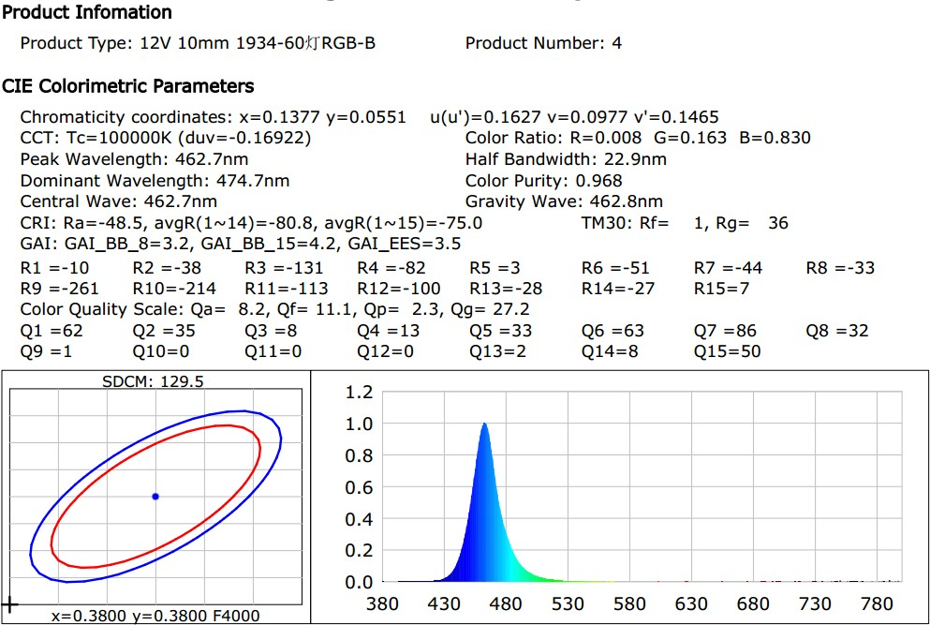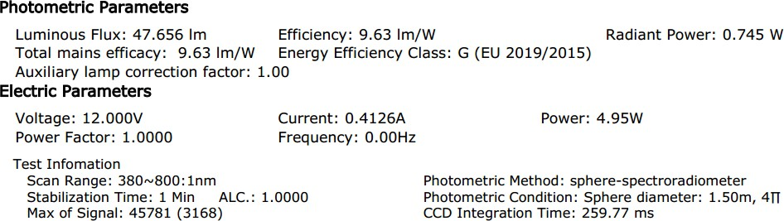

**WHITE**

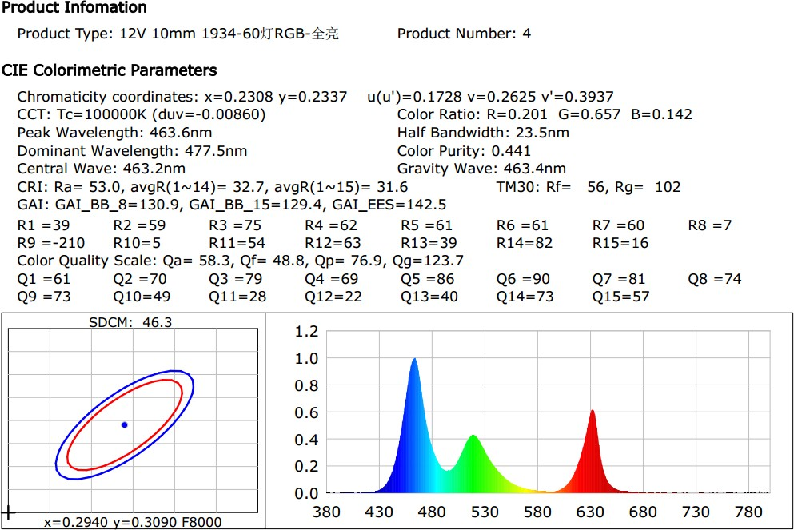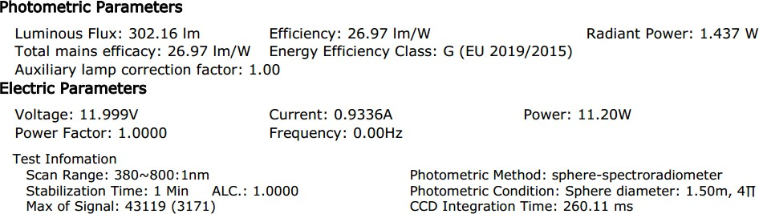

**Packaging Images:**

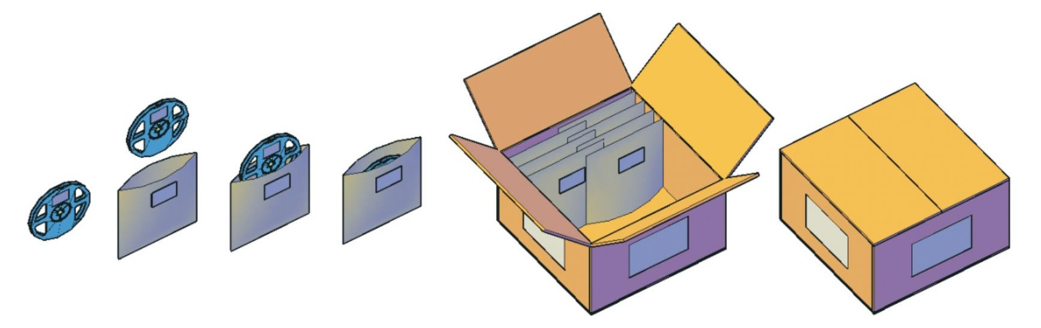

**Note:**

1.One aluminium Foil Bag for one roll of LED strip, 5M/roll. 2.All the packaging materials are RoHS standard.

3.Heavy stuff are not allowed to be loaded above the packaging box.





