Model No. - 11002005
WASH 500 BI

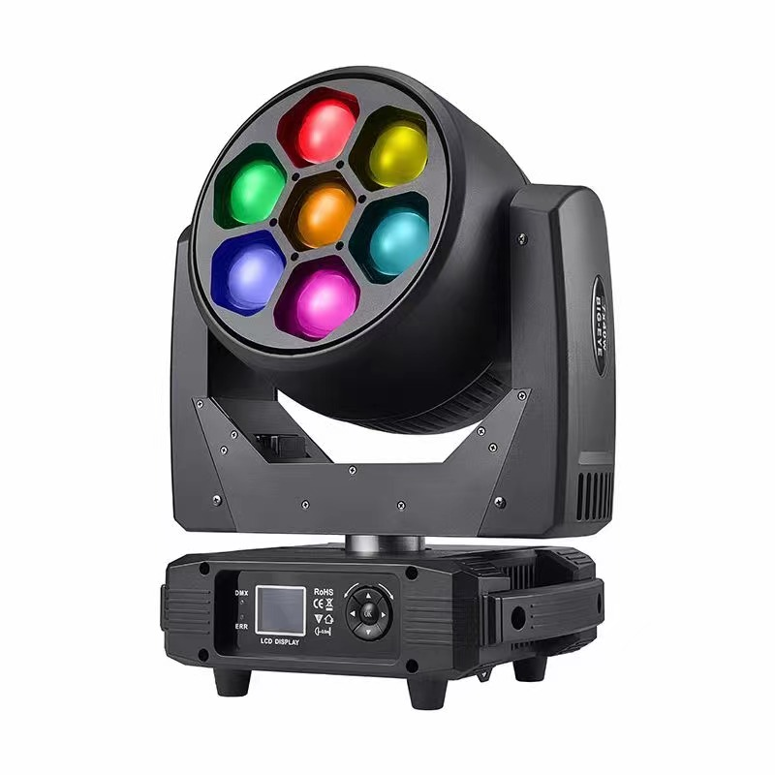

User manual
Please read the instructions carefully before use
TABLE OF CONTENTS
- Safety Instructions 2
- Technical Specifications 4
- How To Control The Unit 6
- Channel 8
- Trouble shooting 13
- Fixture Cleaning 14

Statement
The product has well capability and intact packing when leave factory. All of the user should comply with warning item and manual, any misuse cause of the damages are not included in our guarantee, and also can not be responsible for any malfunction & problem owing to ignore the manual.

Safety Instructions
Please keep this User Guide for future consultation. If you sell the unit to another user, be sure that they also receive this instruction booklet.

 Unpack and check carefully there is no transportation damage before using the unit.
 Before operating, ensure that the voltage and frequency of power supply match the power requirements of the unit.
 It’s important to ground the yellow/green conductor to earth in order to avoid electric shock.  The unit is for indoor use only. Use only in a dry location.
 The unit must be installed in a location with adequate ventilation, at least 50cm from adjacent surfaces. Be sure that no ventilation slots are blocked.
 Disconnect main power before replacement or servicing.

 Make sure there are no flammable materials close to the unit while operating as it is fire hazard.
 Use safety cable when fixes this unit. DO NOT handle the unit by taking its head only, but always by taking its base.

 Maximum ambient temperature is Ta: 40℃. DO NOT operate it where the temperature is higher than this Unit surface temperature may reach up to 85℃. DO NOT touch the housing bare-hand during its operation. Turn off the power and allow about 15 minutes for the unit to cool down before replacing or serving.

 In the event of serious operating problem, stop using the unit immediately.Never try to repair the unit by yourself. Repairs carried out by unskilled people can lead to damage or malfunction. Please contact the nearest authorized technical assistance center. Always use the same type spare parts.

 DO NOT touch any wire during operation as high voltage might be causing electric shock.

Warning:

 To prevent or reduce the risk of electrical shock or fire, do not expose the unit to rain or moisture.
 DO NOT open the unit within five minutes after switching off.

 The housing, the lenses, or the ultraviolet filter must be replaced if they are visibly damaged.

Caution:
There are no user serviceable parts inside the unit. DO NOT open the housing or attempt any repairs yourself. In the unlikely event your unit may require service, please contact your nearest dealer.

Installation:
The unit should be mounted via its screw holes on the bracket. Always ensure that the unit is firmly fixed to avoid vibration and slipping while operating.
And make sure that the structure to which you are attaching the unit is secure and is able to support a weight of 10 times of the unit’s weight. Also always use a safety cable that can hold 12 times of the weight of the unit when installing the fixture.
The equipment must be fixed by professionals. And it must be fixed at a place where is out of the touch of people and has no one pass by or under it.

Technical Specifications
Light Sources: 7x40W RGBW Original LED
Power Voltage: AC 100-240V, 50/60Hz, 500w
Single LED power: 40W
Color: RGBW automatic correction 16.7 million pixels
Electronic dimmer:0～100% linear

Control
DMX Channel: 23/35/51 Channel
Control Modes: DMX512
Software Upgrade: Firmware update via DMX link

Pan/Tilt

Pan/Tilt: 540°

Construction
Display: LCD Display
Data In/Out socket: 3-pin XLR sockets Power Socket: Powercon in/out
Protection Rating: IP20

Features

Motorized liner zoom system,
zoom range: 4.5°~45° Outstanding color macro effect,CTO,Kaleido effects,led single controlled
Dimmer: 0~100% smooth dimming Variable strobe effects
Fast, quiet operation and flicker free
/ 270° Pan/Tilt Resolution: 16 bit

How To Control The Unit
The DMX512 is widely used in intelligent lighting control,with a DMX 512 controller.connect several lights together,dmx in and dmx out,
- pin XLR connectors: Pin 1: GND, Pin 2: Negative signal (-), Pin 3: Positive signal (+)
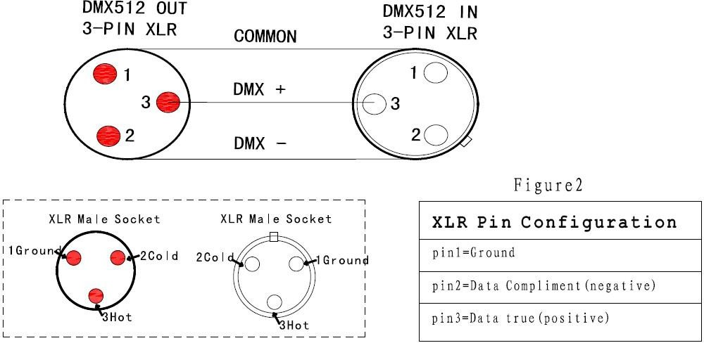

Display:
MENU To select the programming functions DOWN To go backward in the selected functions uP To go forward in the selected functions ENTER To confirm the selected functions

Set DMX Address Code

Press "Menu" to "Set DMX Address",and press"ENTER" keys to enter into Show "Set DMX Address DMX Address:001",Press the "UP and DOWN"
keys to amended
Press "ENTER"keys to save and Exit,Press the"MENU"Keys does not save and Exit
Menu
DmxAddr | 001 - 512
Fix Set | Ch Mode | STD/HIS
Fix Set | Run Mode | DMX/Host
Fix Set | Pan Inv | Close/Open
Fix Set | Tilt Inv | Close/Open
Manual | Pan | 0 - 255
Manual | Pan Fine | 0 - 255
Manual | Tilt | 0 - 255
Manual | Tilt Fine | 0 - 255
Manual | . | 0 - 255
Manual | . | 0 - 255
Manual | . | 0 - 255
Fix Info | TimeInfo | Cur Time | xxxh
Fix Info | TimeInfo | Show Time | xxxh
Fix Info | TimeInfo | PowerCnt | xxx
Fix Info | SenSor | Pan | OK/NG
Fix Info | SenSor | Tilt | OK/NG
Fix Info | SenSor | Zoom | OK/NG
Fix Info | SenSor | Temp | OK/NG
Fix Info | SenSor | Fan | OK/NG

 | TempInfo | Temprat | xxx C
 | TempInfo | FanSpeed | xxxx RPM
 | Soft Ver | Panel | Vx.xxx
 | Soft Ver | Motor | Vx.xxx
Home Set | Password | 0 - 255
Home Set | Pan | 0 - 255
Home Set | Tilt | 0 - 255
Home Set | Zoom | 0 - 255
Home Set | Red | 0 - 255
Home Set | Green | 0 - 255
Home Set | Blue | 0 - 255
Home Set | White | 0 - 255
FixReset | Reset | Cance/Run
FixReset | Factory | Cance/Run
Display | Language | EN/CH
Display | DispFlip | Open/Close
Display | DispMode | Show/60s

DMX channel´s functions and values (23/35/51 DMX channels):
Channel list(23 channels)
chs | function | DMX value | description
1 | X | 0-255 | 0-540 degree
2 | X fine | 0-255 | 16 bit
3 | Y | 0-255 | 0-205 degree
4 | Y fine | 0-255 | 16 bit
5 | XY speed | 0-255 | Fast-slow
6 | zoom | 0-255 | Angle from small-big
7 | rotating | 0-127 | 0~60 degree
7 | rotating | 128-191 | Antiwise fast-slow
7 | rotating | 200-255 | Forward slow-fast
8 | dimmer | 0-255 | From dark-bright
9 | strobe | 0-3 | on
9 | strobe | 4-200 | Synchronous strobe from slow-fast
9 | strobe | 201-215 | Random strobe in low speed
9 | strobe | 216-234 | Random strobe in middle speed
9 | strobe | 235-255 | Random strobe in high speed
10 | R dimmer | 0-255 | From dark-bright
11 | G dimmer | 0-255 | From dark-bright
12 | B dimmer | 0-255 | From dark-bright
13 | W dimmer | 0-255 | From dark-bright
14 | CT | 0-255 | Linear CT control
15 | wash | 0-255 | Inner color gradual change
16 | Static effect | 0-255 | 5 no. One effect
17 | Dynamic effect | 0-255 | 5 no. One effect
18 | Dynamic effect speed | 0-127 | Forward from fast-slow
18 | Dynamic effect speed | 128-255 | Reverse from slow-fast
19 | Background R | 0-255 | Dark-bright
20 | Background G | 0-255 | Dark-bright
21 | Background B | 0-255 | Dark-bright
22 | Background W | 0-255 | Dark-bright
23 | reset | 0-199 | invalid
23 | reset | 200-205 | Reset after 5 seconds
23 | reset | 206-255 | invalid

Channel list(35 channels)
chs | function | DMX value | description
1 | red | 0-255 | Red dimmer
2 | Red fine | 0-255 | Red dimmer fine
3 | green | 0-255 | Green dimmer
4 | Green fine | 0-255 | Green dimmer fine
5 | blue | 0-255 | Blue dimmer
6 | Blue fine | 0-255 | Blue dimmer fine
7 | white | 0-255 | White dimmer
8 | White fine | 0-255 | White dimmer fine
9 | CT | 0-255 | Linear CT control
10 | Color Macro | 0-255 | Color Macro function
11 | strobe | 0-3 | off
11 | strobe | 4-103 | Synchronous strobe slow-fast （1HZ-25HZ）
11 | strobe | 104-107 | on
11 | strobe | 108-207 | Divide strobe from slow-fast （1HZ-25HZ）
11 | strobe | 208-212 | on
11 | strobe | 213-225 | Random strobe in low speed
11 | strobe | 226-238 | Random strobe in middle speed
11 | strobe | 239-251 | Random strobe in high speed
11 | strobe | 252-255 | on
12 | dimmer | 0-255 | Linear dimmer from dark-bright
13 | Dimmer fine | 0-255 | Dimmer fine
14 | pan | 0-255 | pan
15 | Pan fine | 0-255 | Pan fine
16 | tilt | 0-255 | tilt
17 | Tilt fine | 0-255 | Tilt fine
18 | function | 0-255
19 | reset | 0-199 | invalid
19 | reset | 200-205 | Reset after 5 seconds
19 | reset | 206-255 | invalid
20 | zoom | 0-255 | zoom
21 | Lens rotating | 0-127 | 0~60 degree
21 | Lens rotating | 128-191 | Forward limitless rotate
21 | Lens rotating | 192-255 | Reverse limitless rotate
22 | pattern | 0-255 | Pattern rotate
23 | Pattern speed | 0-255 | Pattern speed
24 | Pattern effect fade | 0-255
25 | Pattern effect R | 0-255
26 | Pattern effect G | 0-255
27 | Pattern effect B | 0-255
28 | Pattern effect W | 0-255
29 | Pattern dimmer | 0-255 | Pattern 0-100% dimmer
30 | Background dimmer | 0-255 | Background 0-100% dimmer
31 | Pattern transition | 0-255
32 | Pattern angle | 0-255 | Pattern design
33 | Prospect strobe | 0-255 | Prospect strobe（with 11 chs）
34 | Background strobe | 0-255 | Background strobe（with 11 chs）
35 | Background selection | 0-255

Channel list(51 channels)
chs | function | DMX value | description
1 | X | 0-255 | 0-540 degree
2 | X fine | 0-255 | 16 bit
3 | Y | 0-255 | 0-205 degree
4 | Y fine | 0-255 | 16 bit
5 | XY speed | 0-255 | Fast-slow
6 | zoom | 0-255 | Small-big
7 | rotating | 0-127 | 0~60 degree
7 | rotating | 128-191 | Forward fast-slow
7 | rotating | 200-255 | Reverse slow-fast
8 | dimmer | 0-255 | Dark-bright
9 | strobe | 0-3 | on
9 | strobe | 4-200 | Synchronous strobe slow-fast
9 | strobe | 201-215 | Random strobe in low speed
9 | strobe | 216-234 | Random strobe in midlle speed
9 | strobe | 235-255 | Random strobe in high speed
10 | R dimmer | 0-255
11 | G dimmer | 0-255
12 | B dimmer | 0-255
13 | W dimmer | 0-255
14 | CT | 0-255 | Linear CT control
15 | Wash | 0-255
16 | Static effect | 0-255 | 5 no. One effect
17 | Dynamic effect | 0-255 | 5 no. One effect
18 | Dynamic effect speed | 0-127 | Forward fast-slow
18 | Dynamic effect speed | 128-255 | Reverse slow-fast
19 | Background R | 0-255 | Dark-bright
20 | Background G | 0-255 | Dark-bright
21 | Background B | 0-255 | Dark-bright
22 | Background W | 0-255 | Dark-bright
23 | reset | 0-199 | invalid
23 | reset | 200-205 | Reset after 5s
23 | reset | 206-255 | invalid
24 | R1 LED dimmer | 0-255 | R1 LED dimmer
25 | G1 LED dimmer | 0-255 | G1 LED dimmer
26 | B1 LED dimmer | 0-255 | B1 LED dimmer
27 | W1 LED dimmer | 0-255 | W1 LED dimmer
… | … | …… | ……
… | … | …… | ……
48 | R7 LED dimmer | 0-255 | R7 LED dimmer
49 | G7 LED dimmer | 0-255 | G7 LED dimmer
50 | B7 LED dimmer | 0-255 | B7 LED dimmer
51 | W7 LED dimmer | 0-255 | W7 LED dimmer

Trouble shooting
Following are a few common problems that may occur during operation. Here are some suggestions for easy troubleshooting:

The unit does not work, no light and the fan does not work
- Check the connection of power and main fuse.
- Measure the mains voltage on the main connector.
- Check the power on LED.

Not responding to DMX controller
- DMX LED should be on. If not, check DMX connectors, cables to see if link properly.
- If the DMX LED is on and no response to the channel, check the address settings and DMX polarity.
- If you have intermittent DMX signal problems, check the pins on connectors or on PCB of the unit or the previous one.
- Try to use another DMX controller.

- Check if the DMX cables run near or run alongside to high voltage cables that may cause damage or interference to DMX interface circuit.

One of the channels is not working well
- The stepper motor might be damaged or the cable connected to the PCB is broken.

6. Fixture Cleaning

The cleaning of internal and external optical lenses and/or mirrors must be carried out periodically to optimize light output. Cleaning frequency depends on the environment in which the fixture operates: damp, smoky or particularly dirty surrounding can cause greater accumulation of dirt on the unit’s optics.

Clean with soft cloth using normal glass cleaning fluid.

- Always dry the parts carefully.

- Clean the external optics at least every 20 days. Clean the internal optics at least every 30/60 days.

