Please read the manual carefully before installing and using the product

Use the Instruction Book
830+A595+A622 Double-row Beam Swing with Strobe Manual

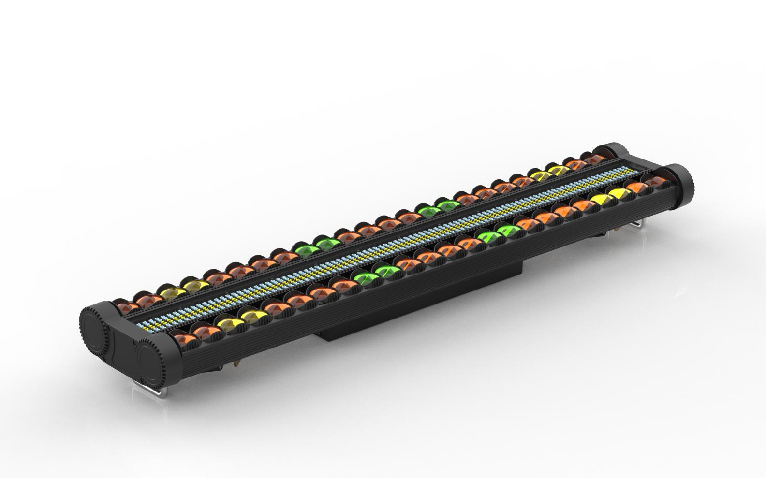

directory

1. Precautions and installation precautions and installation 3
1.1 Notices 3
1.2 Maintenance 3
1.3 Product Precautions 3
1.4 Product Introduction 4
2. Display panel and button definition 4
2.1 Control Panel 4
2.2 Menu Function 5
3. Master-slave control 7
4.DMX512 control 7
4.1 Address Code 7
4.2 CH21 channel table 7
4.3 CH38 channel table 8
4.4 CH86 channel table 9
4.5 CH110 Channel Table 10
4.6 CH369 Channel Table 11
5. Common faults 14

1. Precautions and installation precautions and installation

1.1 Notices
Thank you for choosing our company's products! When this product leaves the factory, the performance is intact and the packaging is complete. In order for you to use this product safely and effectively, please read this instruction manual carefully and completely before you use this product. This manual contains important information for installation and use, please install and operate according to the requirements of the manual, and at the same time, please keep this manual properly so that it can be used at any time.
This manual is subject to technical change without notice.

1.2 Maintenance
- This fixture is for professional use only.
- If the external flexible cable or wire of this luminaire is damaged, it should be replaced with a special wire or wire provided by the manufacturer or its service agent.
- The light source contained in this luminaire should only be replaced by the manufacturer or its service agent or similar qualified person.
- Always connect the product to a protected circuit (circuit breaker or fuse). Ensure that the product has proper electrical grounding to avoid the risk of electric shock or fire.
- To avoid unnecessary wear and tear and prolong its service life, the power supply should be completely cut off by a circuit breaker or unplugged when not in use.
- The housing may generate heat while the product is operating. This product should be installed in a well-ventilated location.
- When a product is transferred from an extreme temperature environment (e.g., from a cold truck to warm and humid), the internal electronics of the product may condense. To avoid failure, allow the product to fully acclimatize to the surrounding environment before turning on the power supply.
- Flashing lights are known to trigger seizures. Users must comply with local notification laws regarding flash use.

1.3 Product Precautions
- Disconnect the power supply before cleaning the product or replacing the fuse.
- When not in use, replace and secure the shields of all power, data, USB, or other ports to IP rating.
- When installing this product above your head, use a safety cord.
- Connect this product to a grounded and protected circuit.
- When the product is turned on, look at the light source.
- Do not place any flammable materials within 20 cm of this product when operating or plugging in a power supply.
- Do not operate the product if the housing, lenses, or cables are damaged.
- Only use handles or hoisting/mounting brackets to handle this product.
- To avoid unnecessary wear and tear and prolong its service life, the power supply should be completely cut off by a circuit breaker or unplugged when not in use.
- In case of serious operational problems, it should be discontinued immediately

1.4 Product Introduction
- Voltage: AC100~240V 50/60HZ
- Power: 253W
- Lamp beads: 24 segments of RGBW3535-8W spherical surface in each row + 384 pieces of 5050 three-color LED lamp beads in 48 segments + 192 pieces of 5730 white light in 24 segments
- Control mode: DMX512, self-propelled, master-slave, with RDM function, with ROBE channel
- Channels: CH21, CH38, CH86, CH110, CH369
- Dimming: 32bit 0~100% linear dimming
- Features: Shake head + dye + focus
- Operating temperature: -30°C~50°C
- Strobe frequency: 1~30HZ
- Appearance: Metallic, black
- Connection: DMX512 input and output / power input and output.
- IP Rating: IP20
- Size: 1075×215×100mm
- Weight: 9.5kg

2. Display panel and button definition

2.1 Control Panel

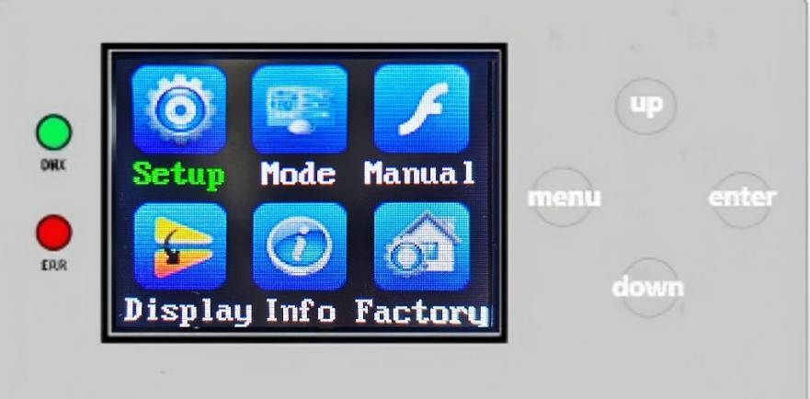

Menu key: Enter/return to the main menu
Up Arrow: Menu function up selection/parameter increment
Down Arrow: Menu function to select down/decrement parameters
Confirm button: Select the menu function, and confirm and save it when the menu function parameters are modified.

2.2 Menu Function
After powering on and resetting the whole machine, press the menu button to enter the main menu (the main menu interface will exit after 30 seconds of no operation), see the main menu function table (a total of 5 main menu options) for details; Up or down key to select the main menu, confirm button to enter the modification of the function parameters of each menu, and then press the confirm button to save the current function parameters (after saving, it has a power-off memory).
Main menu | submenu | Menu function description
1. System settings | 1.DMX address | Modify the DMX address code up or down (the address code can be selected in the range 001-512), and save it with the confirmation key, which is 001 by default.
1. System settings | 2. Encoder | Modify the encoder on/off up or down, confirm key to save, and enable by default.
1. System settings | 3.Y1 reverses | Modify up/down on/off, confirm key save, and enable by default.
1. System settings | 4. Y2 reversal | Modify up/down on/off, confirm key save, and enable by default.
1. System settings | 5. Signal hold | Modify Yes/No up or down, confirm key to save, default no.
1. System settings | 6. Voice-activated sensitivity | Modify up or down (000-099), confirm the key to save, default 009.
1. System settings | 7. Advanced Settings
2. Operation mode | 1. Mode of operation | Up or down select run mode DMX/Auto, confirm key to save, default DMX.
2. Operation mode | 2. Channel selection | Up or down select channels CH21, CH38, CH86, CH110, CH369, default CH38
3. Manual control | 1. Y1 | Modify the parameter value up or down (adjustable range 000-255), save the confirmation key, default 000.
3. Manual control | 2.Y1 fine-tuning | Modify the parameter value up or down (adjustable range 000-255), save the confirmation key, default 000.
3. Manual control | 3.Y1 speed | Modify the parameter value up or down (adjustable range 000-255), save the confirmation key, default 000.
3. Manual control | 4. Y2 | Modify the parameter value up or down (adjustable range 000-255), save the confirmation key, default 000.
3. Manual control | 5. Y2 fine-tuning | Modify the parameter value up or down (adjustable range 000-255), save the confirmation key, default 000.
3. Manual control | 6.Y2 speed | Modify the parameter value up or down (adjustable range 000-255), save the confirmation key, default 000.
3. Manual control | 7.A dimming | Modify the parameter value up or down (adjustable range 000-255), save the confirmation key, default 000.
3. Manual control | 8.A strobe | Modify the parameter value up or down (adjustable range 000-255), save the confirmation key, default 000.
3. Manual control | 9. A red | Modify the parameter value up or down (adjustable range 000-255), save the confirmation key, default 000.
3. Manual control | 10.A green | Modify the parameter value up or down (adjustable range 000-255), save the confirmation key, default 000.
3. Manual control | 11.A blue | Modify the parameter value up or down (adjustable range 000-255), save the confirmation key, default 000.
3. Manual control | 12.A white | Modify the parameter value up or down (adjustable range 000-255), save the confirmation key, default 000.
3. Manual control | 13.A mode | Modify the parameter value up or down (adjustable range 000-255), save the confirmation key, default 000.
3. Manual control | 14.A speed | Modify the parameter value up or down (adjustable range 000-255), save the confirmation key, default 000.
3. Manual control | 15.A background color | Modify the parameter value up or down (adjustable range 000-255), save the confirmation key, default 000.
3. Manual control | 16. A background tint light | Modify the parameter value up or down (adjustable range 000-255), save the confirmation key, default 000.
3. Manual control | 17.B dimming | Modify the parameter value up or down (adjustable range 000-255), save the confirmation key, default 000.
3. Manual control | 18.B strobe | Modify the parameter value up or down (adjustable range 000-255), save the confirmation key, default 000.
3. Manual control | 19.B red | Modify the parameter value up or down (adjustable range 000-255), save the confirmation key, default 000.
3. Manual control | 20.B green | Modify the parameter value up or down (adjustable range 000-255), save the confirmation key, default 000.
3. Manual control | 21.B blue | Modify the parameter value up or down (adjustable range 000-255), save the confirmation key, default 000.
3. Manual control | 22. B white | Modify the parameter value up or down (adjustable range 000-255), save the confirmation key, default 000.
3. Manual control | 23. Model B | Modify the parameter value up or down (adjustable range 000-255), save the confirmation key, default 000.
3. Manual control | 24.B speed | Modify the parameter value up or down (adjustable range 000-255), save the confirmation key, default 000.
3. Manual control | 25.B background color | Modify the parameter value up or down (adjustable range 000-255), save the confirmation key, default 000.
3. Manual control | 26.B background tint light | Modify the parameter value up or down (adjustable range 000-255), save the confirmation key, default 000.
3. Manual control | 27. Directions | Modify the parameter value up or down (adjustable range 000-255), save the confirmation key, default 000.
3. Manual control | 28.F dimming | Modify the parameter value up or down (adjustable range 000-255), save the confirmation key, default 000.
3. Manual control | 29.F strobe | Modify the parameter value up or down (adjustable range 000-255), save the confirmation key, default 000.
3. Manual control | 30.F red | Modify the parameter value up or down (adjustable range 000-255), save the confirmation key, default 000.
3. Manual control | 31.F green | Modify the parameter value up or down (adjustable range 000-255), save the confirmation key, default 000.
3. Manual control | 32.F blue | Modify the parameter value up or down (adjustable range 000-255), save the confirmation key, default 000.
3. Manual control | 33.F white | Modify the parameter value up or down (adjustable range 000-255), save the confirmation key, default 000.
3. Manual control | 34.F mode | Modify the parameter value up or down (adjustable range 000-255), save the confirmation key, default 000.
3. Manual control | 35.F speed | Modify the parameter value up or down (adjustable range 000-255), save the confirmation key, default 000.
3. Manual control | 36.F background color | Modify the parameter value up or down (adjustable range 000-255), save the confirmation key, default 000.
3. Manual control | 37.F background tint light | Modify the parameter value up or down (adjustable range 000-255), save the confirmation key, default 000.
3. Manual control | 38. Reset | Modify the parameter value up or down (adjustable range 000-255), save the confirmation key, default 000.
4. Display settings | 1. Language selection | Select Chinese/EN (English) up or down, confirm the key to save, default Chinese.
4. Display settings | 2. Invert settings | Up or down select Off/On Inverted Settings, Confirm key Save, and turn off by default.
4. Display settings | 3. Screensaver settings | Up or down select Turn off/on screen saver and confirm that it is on by default.
4. Display settings | 4. Software Version | G7VA program identification code, non-modifiable.
5. Factory setting | DisplayPlease enter password! Modify it up or down to 138, and then press the confirm button to enter the factory settings. | 1. Y1 axis calibration | Modify the parameter value (000-255) up or down, and save it with the confirmation key, which is 128 by default.
5. Factory setting |  | 2. Y2 axis calibration | Modify the parameter value (000-255) up or down, and save it with the confirmation key, which is 128 by default.
5. Factory setting |  | 3.A red | Modify the parameter value (000-255) up or down, and save it with the confirmation key, which is 152 by default.
5. Factory setting |  | 4.A green | Modify the parameter value (000-255) up or down, and save the confirmation key, which is 113 by default.
5. Factory setting |  | 5.A blue | Modify the parameter value (000-255) up or down, and save it with the confirmation key, which is 117 by default.
5. Factory setting |  | 6.A white | Modify the parameter value (000-255) up or down, and save the confirmation key, which is 120 by default.
5. Factory setting |  | 7.B red | Modify the parameter value (000-255) up or down, and save it with the confirmation key, which is 152 by default.
5. Factory setting |  | 8.B green | Modify the parameter value (000-255) up or down, and save the confirmation key, which is 113 by default.
5. Factory setting |  | 9.B blue | Modify the parameter value (000-255) up or down, and save it with the confirmation key, which is 117 by default.
5. Factory setting |  | 10.B white | Modify the parameter value (000-255) up or down, and save the confirmation key, which is 120 by default.
5. Factory setting |  | 11.F red | Modify the parameter value (000-255) up or down, and save it with the confirmation key, which is 255 by default.
5. Factory setting |  | 12.F green | Modify the parameter value (000-255) up or down, and save it with the confirmation key, which is 255 by default.
5. Factory setting |  | 13.F blue | Modify the parameter value (000-255) up or down, and save it with the confirmation key, which is 255 by default.
5. Factory setting |  | 14.F white | Modify the parameter value (000-255) up or down, and save it with the confirmation key, which is 255 by default.
5. Factory setting |  | 15.Logo | Select 000 /001 up or down, confirm the key to save, and 000 is the default.
5. Factory setting |  | 16. Temperature | Modify the parameter value up or down (range 40-70), and save the confirmation key, default 055.
5. Factory setting |  | 17. Temperature - Fan | Up or down select Off/On Temperature-Fan Control, Confirm key Save, Off by default.
5. Factory setting |  | 18.LED | Select LEDA/LEDB/LEDC/LEDD up or down, confirm key to save, default LEDA.
5. Factory setting |  | 19.LEDF | Select LEDA/LEDB up or down, confirm that the key is saved, and LEDA is the default.
 |  | 20.ETOA | Modify the parameter value (000-255) up or down, and save the confirmation key, which is 120 by default.
 |  | 21.ETOB | Modify the parameter value (000-255) up or down, and save the confirmation key, which is 120 by default.
 |  | 22.ETOF | Modify the parameter value (000-255) up or down, and save it with the confirmation key, which is 255 by default.
 |  | 23. Directions | Modify 000/001 up or down, confirm the key to save, default 000.

3. Master-slave control
There are 2 or more identical lamps connected with DMX three-core signal cable, all lamps and lanterns are modified to 001~512 arbitrary address code, set any one as the host, and other lamps and lanterns are slaves, and all slave display screens do not flash; When using the master to adjust the gradient, pulse, jump, voice-activated and self-propelled effects, all slaves synchronize the gradient, pulse, jump, voice-activated and self-propelled effects.
Special attention: 1. A group of lamps can only be set up with one host, if there are multiple hosts, all lamps will flash randomly and not synchronized.
- All fixtures must be active when the DMX512 console is turned off.

4.DMX512 control

4.1 Address Code
The address code of all lamps and lanterns is set, and all lamps are connected to the DMX512 console in parallel with DMX three-core signal cables, and the address code stops flashing, indicating that the DMX512 console signal has been sent to the lamps, and the DMX512 console is used to control the relevant functions according to the channel instructions.

4.2 CH21 channel table
passage | Channel name | value
1 | Y1 | 000-255
2 | Y1 fine-tuning | 000-255
3 | Y1 speed | 000-255
4 | Y2 | 000-255
5 | Y2 fine-tuning | 000-255
6 | Y2 speed | 000-255
7 | Dimming | 000-255
8 | Strobe | 0-9 invalid  10-255 Slow to fast
9 | AR | 000-255
10 | AG | 000-255
11 | AB | 000-255
12 | AW | 000-255
13 | BR | 000-255
14 | BG | 000-255
15 | BB | 000-255
16 | BW | 000-255
17 | FR | 000-255
18 | FG | 000-255
19 | FB | 000-255
20 | FW | 000-255
21 | reposition | 000-255

4.3 CH38 channel table
passage | Channel name | value
1 | Y1 | 000-255
2 | Y1 fine-tuning | 000-255
3 | Y1 speed | 000-255
4 | Y2 | 000-255
5 | Y2 fine-tuning | 000-255
6 | Y2 speed | 000-255
7 | A dimming | 000-255
8 | A strobe | 0-9 invalid 10-255 slow to fast
9 | AR | 000-255
10 | AG | 000-255
11 | AB | 000-255
12 | AW | 000-255
13 | A mode | 0-2 Invalid  3-236 3 values per effect, 78 effects in total,  237-255 Combined effects
14 | A speed | 000-255
15 | A background color | (A/B Background color) with channels 13 (A mode) 12-134
16 | A background dimming | 000-255
17 | B dimming | 000-255
18 | B strobe | 0-9 invalid 10-255 slow to fast
19 | BR | 000-255
20 | BG | 000-255
21 | BB | 000-255
22 | BW | 000-255
23 | Model B | 0-2 Invalid  3-236 3 values per effect, 78 effects in total,  237-255 Combined effects
24 | B speed | 000-255
25 | B background color | (A/B Background color) with channel 23 (B mode) 12-134
26 | B background dimming | 000-255
27 | direction | 0-63 invalid  64-128 Direction 1  128-193 Direction 2  192-255 Direction 3
28 | F dimming | 000-255
29 | F strobe | 0-9 invalid  10-255 slow to fast
30 | FR | 000-255
31 | FG | 000-255
32 | FB | 000-255
33 | FW | 000-255
34 | F-mode | 0-2 Invalid  3-236 3 values per effect, 78 effects in total,  237-255 Combined effects
35 | F speed | 000-255
36 | Background color | (F Background color)
37 | F background dimming | 000-255
38 | reposition | 000-255

4.4 CH86 channel table
passage | Channel name | value
1 | Y1 | 000-255
2 | Y1 fine-tuning | 000-255
3 | Y1 speed | 000-255
4 | Y2 | 000-255
5 | Y2 fine-tuning | 000-255
6 | Y2 speed | 000-255
7 | A dimming | 000-255
8 | A strobe | 0-9 invalid  10-255 slow to fast
9 | AR | 000-255
10 | AG | 000-255
11 | AB | 000-255
12 | AW | 000-255
13 | A mode | 0-2 Invalid  3-236 3 values per effect, 78 effects in total,  237-255 Combined effects
14 | A speed | 000-255
15 | A background color | (A/B Background color) with channels 13 (A mode) 12-134
16 | A background dimming | 000-255
17 | B dimming | 000-255
18 | B strobe | 0-9 invalid  10-255 slow to fast
19 | BR | 000-255
20 | BG | 000-255
21 | BB | 000-255
22 | BW | 000-255
23 | Model B | 0-2 Invalid  3-236 3 values per effect, 78 effects in total,  237-255 Combined effects
24 | B speed | 000-255
25 | B background color | (A/B Background color) with channel 23 (B mode) 12-134
26 | B background dimming | 000-255
27 | direction | 0-63 invalid  64-128 Direction 1  128-193 direction 2  192-255 direction 3
28 | F dimming | 000-255
29 | F strobe | 0-9 invalid ,10-255 slow to fast
30 | FR | 000-255
31 | FG | 000-255
32 | FB | 000-255
33 | FW | 000-255
34 | F-mode | 0-2 Invalid  3-236 3 values per effect, 78 effects in total,  237-255 Combined effects
35 | F speed | 000-255
36 | Background color | (F Background color)
37 | F background dimming | 000-255
38 | reposition | 000-255
39 | ALED1 | 000-255
… | … … | … …
62 | ALED24 | 000-255
63 | BLED1 | 000-255
… | … … | … …
86 | BLED24 | 000-255

4.5 CH110 Channel Table
passage | Channel name | value
1 | Y1 | 000-255
2 | Y1 fine-tuning | 000-255
3 | Y1 speed | 000-255
4 | Y2 | 000-255
5 | Y2 fine-tuning | 000-255
6 | Y2 speed | 000-255
7 | A dimming | 000-255
8 | A strobe | 0-9 invalid  10-255 slow to fast
9 | AR | 000-255
10 | AG | 000-255
11 | AB | 000-255
12 | AW | 000-255
13 | A mode | 0-2 Invalid  3-236 3 values per effect, 78 effects in total,  237-255 Combined effects
14 | A speed | 000-255
15 | A background color | (A/B Background color) with channels 13 (A mode) 12-134
16 | A background dimming | 000-255
17 | B dimming | 000-255
18 | B strobe | 0-9 invalid  10-255 slow to fast
19 | BR | 000-255
20 | BG | 000-255
21 | BB | 000-255
22 | BW | 000-255
23 | Model B | 0-2 Invalid  3-236 3 values per effect, 78 effects in total,  237-255 Combined effects
24 | B speed | 000-255
25 | B background color | (A/B Background color) with channel 23 (B mode) 12-134
26 | B background dimming | 000-255
27 | direction | 0-63 invalid  64-128 Direction 1  128-193 direction 2  192-255 direction 3
28 | F dimming | 000-255
29 | F strobe | 0-9 invalid  10-255 slow to fast
30 | FR | 000-255
31 | FG | 000-255
32 | FB | 000-255
33 | FW | 000-255
34 | F-mode | 0-2 Invalid  3-236 3 values per effect, 78 effects in total,  237-255 Combined effects
35 | F speed | 000-255
36 | Background color | (F Background color)
37 | F background dimming | 000-255
38 | reposition | 000-255
39 | FRGB1 | 000-255
… | … … | … …
86 | FRGB48 | 000-255
87 | FW1 | 000-255
… | … … | … …
110 | FW24 | 000-255

4.6 CH369 Channel Table
passage | Channel name | value
1 | Y1 | 000-255
2 | Y1 fine-tuning | 000-255
3 | Y1 speed | 000-255
4 | Y2 | 000-255
5 | Y2 fine-tuning | 000-255
6 | Y2 speed | 000-255
7 | Dimming | 000-255
8 | Strobe | 000-255
9 | AR1 | 000-255
10 | AG1 | 000-255
11 | AB1 | 000-255
12 | AW1 | 000-255
… | … … | … …
101 | AR24 | 000-255
102 | AG24 | 000-255
103 | AB24 | 000-255
104 | AW24 | 000-255
105 | BR1 | 000-255
106 | BG1 | 000-255
107 | BB1 | 000-255
108 | BW1 | 000-255
… | … … | … …
197 | BR24 | 000-255
198 | BG24 | 000-255
199 | BB24 | 000-255
200 | BW24 | 000-255
201 | FR1 | 000-255
202 | FG1 | 000-255
203 | FB1 | 000-255
… | … … | … …
342 | FR48 | 000-255
343 | FG48 | 000-255
344 | FB48 | 000-255
345 | FW1 | 000-255
… | … … | … …
368 | FW24 | 000-255
369 | reposition | 000-255

A/B Background color
passage | Channel value | Basic functions
1 | 0-7 | void
2 | 8-11 | Color 1 (4 values for one color, the same as below)
3 | 12-15 | Color 2
… | … | … …
62 | 248-251 | Color 61
63 | 252-255 | Color 62

F Background color
passage | Channel value | Basic functions
1 | 0-9 | void
2 | 10-15 | Color 1 (6 values in one color, the same as below)
3 | 16-21 | Color 2
… | … | … …
62 | 248-251 | Color 40
63 | 252-255 | Color 41

Common faults
In view of some common faults, corresponding solutions are proposed. Any unsolvable problem should be handled by a professional. Disconnect the power supply before maintaining the fixture.
- The lamp beads are not lit
- Check that the voltage that matches the luminaire is installed;
- Check whether the power supply connection or control switch of the lamp is in poor contact;
- Check if the power supply is insufficient;
- Check if the DMX512 controller is sending instructions.
2. The lamp does not accept the control of the console after normal reset
- Check whether the numerical start address value and function options of the lamp are correct;
- Check whether the connection of the communication control line is correct, the communication line is too long or has been interrupted;
- Check whether the control equipment is invalid, and check whether the signal amplifier connected in series is invalid;
- Check whether the communication line is too long or other equipment interferes with each other;
- Optimize the wiring, shorten the length of the control signal line, and separate the wiring of high-voltage and low-voltage lines;
- add a signal amplifier;
- The signal line adopts high-quality shielded twisted pair cable;
- Connect a signal termination resistor (120 ohms) at the end of the luminaire.
3. The lamp cannot be activated
- Check whether the power supply parameters are consistent with the lamp;
- Check that the lamps have poor contact or fall off due to extrusion deformation, internal parts vibration, moisture and other reasons during long-distance transportation.
- Please check whether the internal wires and connectors of the lamp are falling off or loose.
- Check whether the electronic components of the lamp (such as electronic transformers, PCB boards, motor control boards, etc.) are loose, short-circuited and burned.

