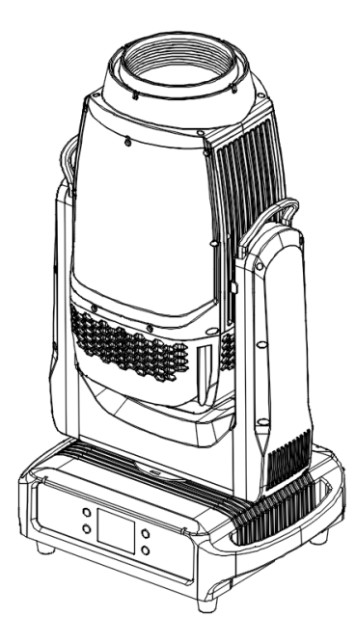

User Manual
Please read the instructions carefully before use

Contents
1. Safety Instructions 1
2. Product Introduction 3
2.1 Product Dimension 4
2.2 Photometric Diagram 5
3. Control Panel 6
4. Lighting installation 7
5. Lighting setup 8
6. Control By Universal DMX Controller 10
6.1 DMX512 Connection 10
6.2 Address Setting 11
6.3 DMX Channel 11
7. Troubleshooting 15
8. Equipment cleaning 15

1. Safety Instructions
Important:
Damages caused by the disregard of this user manual are not subject to warranty. The dealer will not accept liability for any resulting defects or problems.
- Unpack and check carefully to ensure that there is no transportation damage before using the unit
- The equipment is suitable for dry and humid environments,with a protection grade of IP66. The lamps should be kept clean and should be cleaned and maintained regularly.
- Eligible professionals may install,operate, and maintain lighting equipment,and ensure that operations are strictly carried out in accordance with the procedures described in this manual.
- When securing equipment,use safe ropes. When moving lighting fixtures, please also support the bottom.
- The unit must be installed in a location with adequate ventilation, at least 50cm from adjacent surfaces.
- Make sure the power voltage before operation matches the power voltage required by the device.
- Each lighting fixture should be safely grounded and installed in accordance with relevant standards to prevent electric shock.
- Minimum ambient temperature TA: -10℃. Maximum ambient temperature TA: 40℃. Do not operate this product at a lower or higher temperature.
- During initial start-up some smoke or smell may arise. This is a normal process and does not necessarily mean that the device is defective, and it will decrease gradually within 15 minutes.
- Do not place flammable items next to the lighting when in operation to prevent fire hazards.
- Do not use power cables with damaged insulation,and do not place the power cable on other conductors. When the lighting is not in use or being cleaned,please unplug the power cable,do not pull or tug the power cable forcefully.
- Unit’s surface temperature may reach up to 85℃. DO NOT touch the housing bare-handed during its operation.
- Avoid any flammable liquids, water or metal from entering the unit. Once it happens, cut off the mains power immediately.
- Do not touch the wires when the lighting is operating to prevent electric shock.
- The distance between the lighting and the illuminated surface should be greater than 12 meters.
- No available parts inside the lighting fixture,do not open the fixture shell arbitrarily.
- Machine failure occurred, please stop using it immediately. Non-professional technicians are not allowed to repair it themselves
- Please use the original packaging materials when transportation is required again.
- Replace the light bulb in a timely manner when it is damaged,warped due to heat, or exceeds its service life.
- Do not stare directly at the lights when they are in operation.

2. Product Introduction
Technical specification table
Power Voltage | AC100V-240V 50/60HZ
Power Consumption | 600W
Light Source | Ushio 450
Color temperature | 7600±500K
Light source lifespan | 3500 hours
Beam angle | 2°-31°
Outcoating diameter | 140mm
PAN scan | 540°
TILT scan | 270°
Color | Linear CMY color mixing；2 Color Wheels with 12 Colors
Gobo Wheel | 1 Static Gobo Wheel 14gobos;1 Rotating Gobo Whee7 interchangeable gobos
Focus | 0-100% Electronic High-Definition Focus
Frost | 1 Frost Filter
Strobe | 1-20Hz, various strobe effects
Dimming | 0-100% smooth dimming
Prism | 8-facet prism , 6 facet linear prism
Power connection | Waterproof power connector in/out
DMX connection | 3-pin/5-pin XLR Connector
Working temperature | -10℃～+40℃
Dimensions | 709*386*290mm
Weight | 27kg
Protection Rating | IP66
Shell | All-magnesium alloy body with black baked finish
Control Mode | DMX512, Master-Slave, Auto Run, RDM
DMX Channel | 28CH
Display | 2.8-inch Display Screen with Automatic Flip Function

2.1 Product Dimension
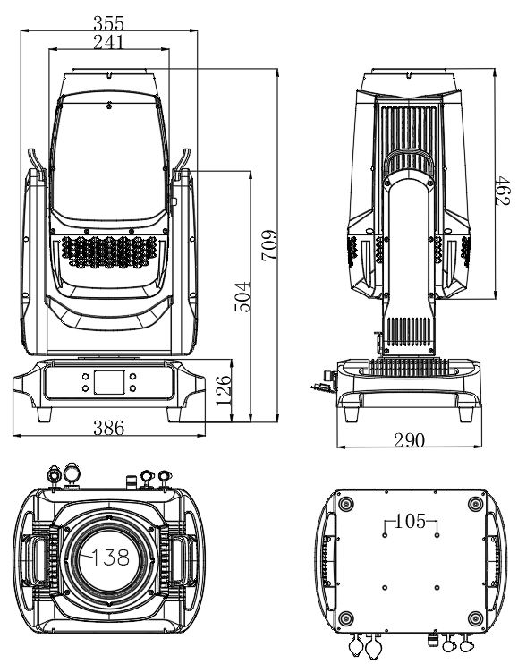

2.2 Photometric Diagram
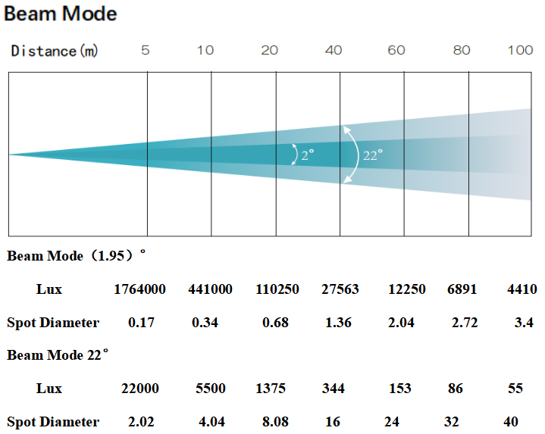

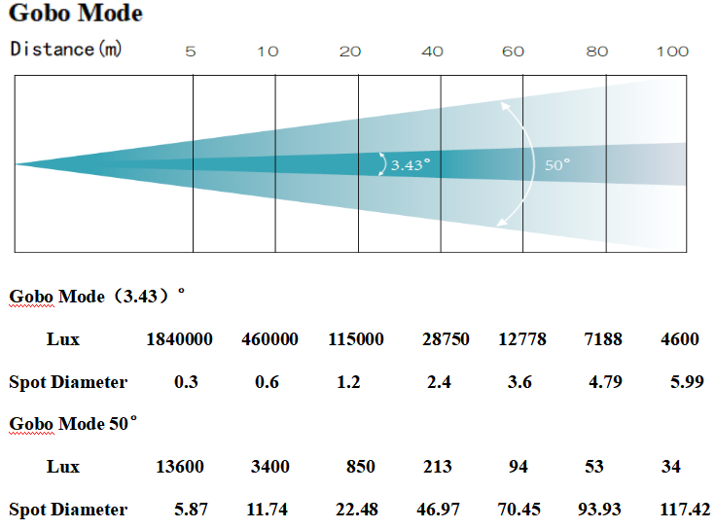

3. Control Panel
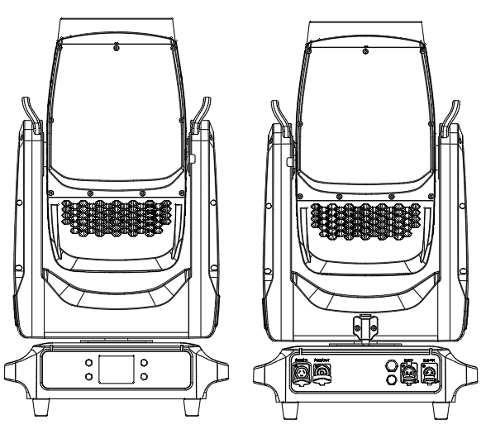
3
2
4
5
6
1
1. Display panel | MENU | Enter the menu function
1. Display panel | ▲UP | UP | To go backward to move up in the menu
1. Display panel | ▼DOWN | DOWN | To go forward to move down in the menu
1. Display panel | ENTER | ENTER | To perform the desired functions
2. Power In | To connect to supply power
3. Power Out | To connect to the next fixture
4.RELEASE VALVE
5.DMX In | For DMX512 link, use 3-pin XLR cable to link the unit and DMX controller
6.DMX Out | For DMX512 link, use 3-pin XLR cable to link the next units

This product uses IP65 waterproof power cable IN/OUT
Note: Due to power reasons, a 1.5 square millimeter power cable can only power a maximum of 4 units (230V), and 120V can only power a maximum of 2 units

4. Lighting installation
- The installation of the equipment should be carried out by professionals,and the area where the lighting fixtures may be accessible to unauthorized personnel should be kept away. Do not stand directly below the lighting fixtures when assembling,disassembling,or repairing them.
- When installing lighting fixtures, make sure they are securely installed to prevent them from shaking and falling off during operation.Also,ensure that the structure used to fix the lighting fixtures can support 10 times the weight of the fixtures without deforming.At the same time as installing the lighting fixtures,use a safety rope that can support 12 times the weight of the fixtures to ensure that the fixtures will not fall off if the clamp fails.
- This lamp is fully operable in three different installation positions:suspended,hanging,or placed on a flat horizontal surface. Always use and install the attached safety rope as a safety measure to prevent the lamp from being accidentally damaged or causing personal injury when the fixture fails.

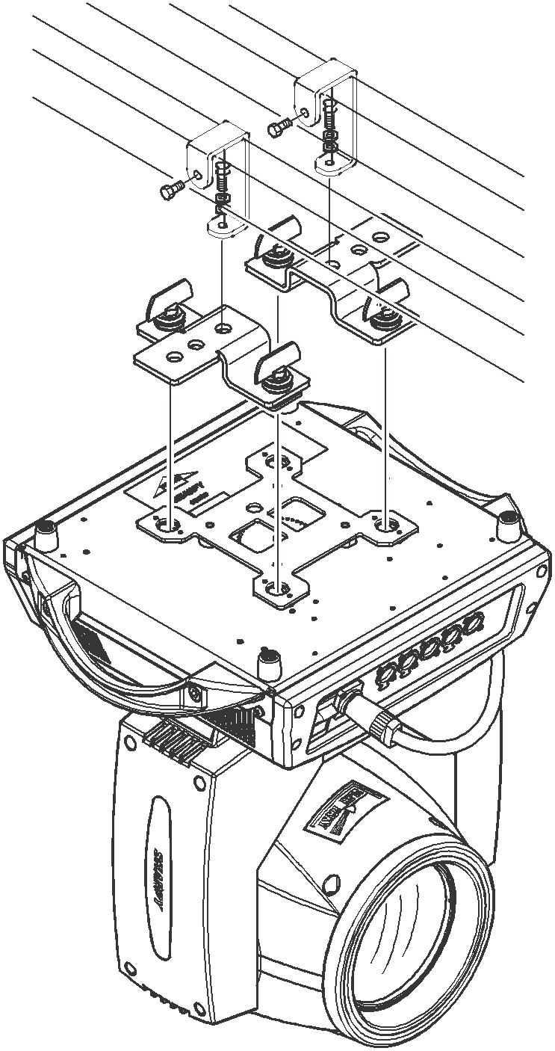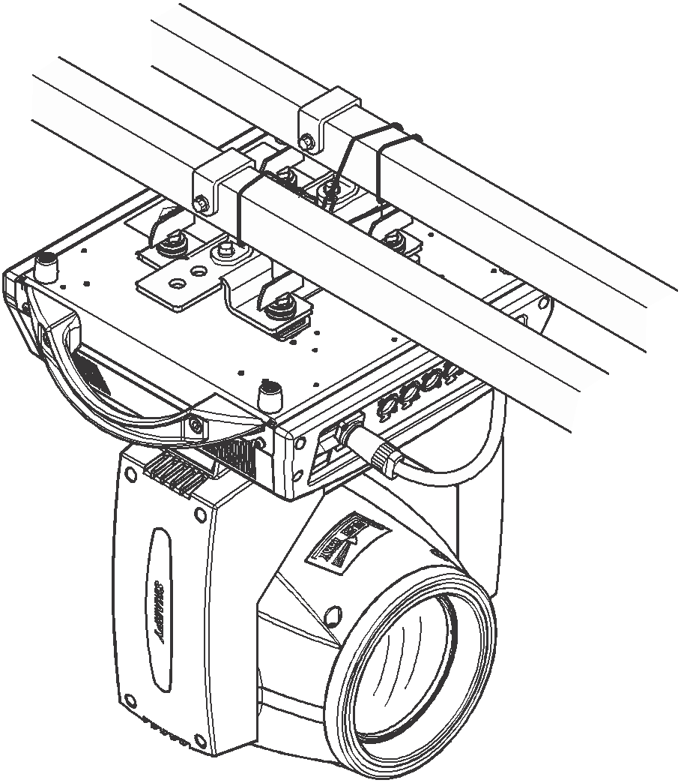

5. Lighting setup
Menu function
- First use requires unlocking the menu, press the [▲UP] and [▼DOWN] buttons twice,then press the [ENTER] key to unlock.
- Use the [ENTER],[▲UP],and [▼DOWN] buttons to navigate the menu.
- Press the [ENTER] button to select menu options or confirm the selected settings.
- Return to the previous menu without making any changes. Press the [MENU] button to return and exit.
- Long-time inactivity will automatically lock the screen of the lighting equipment,which needs to be unlocked by pressing the [▲ UP] and [▼ DOWN] buttons twice in sequence and then pressing the [ENTER] key.
Menu functions as follows
Level 1 Menu | Level 2 Menu | Level 3 Menu | Level 4 Menu |  | Level 5 Menu
DMX Setup | Dmx Address | 1 - 512
DMX Setup | Channel Mode | 28CH
DMX Setup | Run Mode | DMX
DMX Setup | Run Mode | Auto
DMX Setup | Run Mode | Scene
Personality | Pan Inverse | No
Personality | Pan Inverse | Yes
Personality | Tilt Inverse | No
Personality | Tilt Inverse | Yes
Personality | Pan/Tilt Feedback | Off
Personality | Pan/Tilt Feedback | On
Personality | No Data Mode | Blackout
Personality | No Data Mode | Hold
Personality | M/S Mode | Slave
Personality | M/S Mode | Master
Personality | Lamp Mode | Manual
Personality | Lamp Mode | Reset
Personality | Lamp | Off
Personality | Lamp | On
Display | Display Rotate | Normal
Display | Display Rotate | Rotate 180
Display | Screen Lock | Off
Display | Screen Lock | On
Display | Language | English
Display | Language | Chinese
Motor Reset | All | No
Motor Reset | All | Yes
Motor Reset | Pan/Tilt | No
Motor Reset | Pan/Tilt | Yes
Motor Reset | Effect | No
Motor Reset | Effect | Yes
Manual Control | 。。。 | 0 - 255
Scene Editing | Scene1 | Scene state
Scene Editing | Scene1 | Hold time
Scene Editing | Scene1 | 。。。
Scene Editing | Scene2
Scene Editing | Scene3
DMX Live | 。。。 | 0 - 255
Service | Password | Calibration | Motor | Pan |  | -128 ->127
 |  |  |  | 。。。 |  | -128 ->127
Service | Password | Factory Default | No
Service | Password | Factory Default | Yes
Service | Password | Clear Power On Time | No
Service | Password | Clear Power On Time | Yes
Service | Password | Clear Lamp Hours | No
Service | Password | Clear Lamp Hours | Yes
Information | Power On Time | xxxxxH
Information | Lamp Hours | xxxxxH
Information | SW Version | 1U：Vx.x.x
Information | SW Version | 2U：Vx.x.x
Information | SW Version | 3U：Vx.x.x
Information | RDM UID | 0xXXXX-XXXXXXXX

6. Control By Universal DMX Controller

6.1 DMX512 Connection
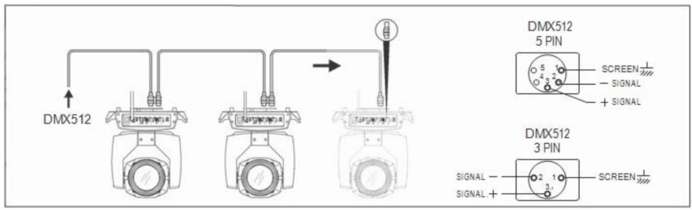
DMX signal line connection diagram
- At last unit, the DMX cable has to be terminated with a terminator. Solder a 120-ohm 1/4W resistor between pin 2(DMX-) and pin 3(DMX+) into a 3-pin XLR-plug and plug it in the DMX-output of the last unit.
- Connect the unit together in a “daisy chain” by XLR plug cable from the output of the unit to the input of the next unit. The cable can only be used in series and cannot be connected in parallel. DMX 512 is a very high-speed signal. Inadequate or damaged cables, soldered joints or corroded connectors can easily distort the signal and shut down the system.
- The DMX output and input connectors are pass-through to maintain the DMX circuit, when one of the units’ power is disconnected.
- Each lighting unit needs to have a DMX address to receive the data by the controller. The address number is between 1-512.
- Each lighting unit needs to have a DMX address to receive the data by the controller. The address number is between 1-512.
- 3 pin XLR connectors are more popular than 5 pins XLR.
3 pin XLR: Pin 1: GND, Pin 2: Negative signal (-), Pin 3: Positive signal (+)
5 pin XLR: Pin 1: GND, Pin 2: Negative signal (-), Pin 3: Positive signal (+), Pin4, Pin5 not used.

6.2 Address Setting
If you use a universal DMX controller to control the units, you have to set DMX address from 1 to 512 so that the units can receive DMX signal.
Press the MENU button to enter the main menu, select DMX settings, press the ENTER button to confirm,use the UP/DOWN buttons to select the address code (1-512,and press the ENTER button to save.
Please refer to the following diagram to address your DMX512 channel for the first 4 units.=
Channel | Address | Unit 1 Address | Unit 2 Address | Unit 3 Address | Unit 4 Address
28CH | 001-028 | 001 | 029 | 057 | 085

6.3 DMX Channel
Channel | NAME | VALUE |  |  | DERIF
28CH | NAME |  |  |  | DERIF
1 | Pan | 000 | - | 255 | 0-540°
2 | PanFine | 000 | - | 255 | 0-2°
3 | Tilt | 000 | - | 255 | 0-270°
4 | TiltFine | 000 | - | 255 | 0-1.2°
5 | PanTiltSpeed | 000 | - | 255 | Speed up and slow down
6 | Strobe | 000 | - | 003 | OFF
6 | Strobe | 004 | - | 103 | Pulse frequency flashes from slow to fast
6 | Strobe | 104 | - | 107 | open
6 | Strobe | 108 | - | 207 | fast
6 | Strobe | 208 | - | 212 | open
6 | Strobe | 213 | - | 251 | Random strobe slow to fast
6 | Strobe | 252 | - | 255 | open
7 | Dimmer | 000 | - | 255 | 0-100%
8 | DimmerFine | 000 | - | 255 | 0-100%
9 | Cyan | 000 | - | 255 | From shallow to deep
10 | Magenta | 000 | - | 255 | From shallow to deep
11 | Yellow | 000 | - | 255 | From shallow to deep
12 | CTO | 000 | - | 255 | From shallow to deep
13 | Colour1 | 000 | - | 007 | white
13 | Colour1 | 008 | - | 016 | Color 1
13 | Colour1 | 017 | - | 025 | Color 2
13 | Colour1 | 026 | - | 034 | Color 3
13 | Colour1 | 035 | - | 043 | Color 4
13 | Colour1 | 044 | - | 052 | Color 5
13 | Colour1 | 053 | - | 063 | Color 6
13 | Colour1 | 064 | - | 067 | white
13 | Colour1 | 068 | - | 071 | white+Color1
13 | Colour1 | 072 | - | 075 | Color1
13 | Colour1 | 076 | - | 079 | Color1+颜Color2
13 | Colour1 | 080 | - | 083 | Color2
13 | Colour1 | 084 | - | 087 | Color2+Color3
13 | Colour1 | 088 | - | 091 | Color3
13 | Colour1 | 092 | - | 095 | Color3+Color4
13 | Colour1 | 096 | - | 099 | Color4
13 | Colour1 | 100 | - | 103 | Color4+Color5
13 | Colour1 | 104 | - | 107 | Color5
13 | Colour1 | 108 | - | 111 | Color5+Color6
13 | Colour1 | 112 | - | 115 | Color6
13 | Colour1 | 116 | - | 255 | white
14 | Colour2 | 000 | - | 007 | white
14 | Colour2 | 008 | - | 016 | Color 1
14 | Colour2 | 017 | - | 025 | Color 2
14 | Colour2 | 026 | - | 034 | Color 3
14 | Colour2 | 035 | - | 043 | Color 4
14 | Colour2 | 044 | - | 052 | Color 5
14 | Colour2 | 053 | - | 063 | Color 6
14 | Colour2 | 064 | - | 067 | white
14 | Colour2 | 068 | - | 071 | white+Color1
14 | Colour2 | 072 | - | 075 | Color1
14 | Colour2 | 076 | - | 079 | Color1+Color2
14 | Colour2 | 080 | - | 083 | Color2
14 | Colour2 | 084 | - | 087 | Color2+Color3
14 | Colour2 | 088 | - | 091 | Color3
14 | Colour2 | 092 | - | 095 | Color3+Color4
14 | Colour2 | 096 | - | 099 | Color4
14 | Colour2 | 100 | - | 103 | Color4+Color5
14 | Colour2 | 104 | - | 107 | Color5
14 | Colour2 | 108 | - | 111 | Color5+Color6
14 | Colour2 | 112 | - | 115 | Color6
14 | Colour2 | 116 | - | 255 | white
15 | FixGobo | 000 | - | 004 | white
15 | FixGobo | 005 | - | 009 | GOBO 1
15 | FixGobo | 010 | - | 014 | GOBO 2
15 | FixGobo | 015 | - | 019 | GOBO 3
15 | FixGobo | 020 | - | 024 | GOBO 4
15 | FixGobo | 025 | - | 029 | GOBO 5
15 | FixGobo | 030 | - | 034 | GOBO 6
15 | FixGobo | 035 | - | 039 | GOBO 7
15 | FixGobo | 040 | - | 044 | GOBO 8
15 | FixGobo | 045 | - | 049 | GOBO 9
15 | FixGobo | 050 | - | 054 | GOBO 10
15 | FixGobo | 055 | - | 059 | GOBO 11
15 | FixGobo | 060 | - | 064 | GOBO 12
15 | FixGobo | 065 | - | 069 | GOBO 13
15 | FixGobo | 070 | - | 074 | GOBO 14
15 | FixGobo | 075 | - | 079 | Pattern 2 shakes from slow to fast
15 | FixGobo | 080 | - | 084 | Pattern 3 shakes from slow to fast
15 | FixGobo | 085 | - | 089 | Pattern 4 shakes from slow to fast
15 | FixGobo | 090 | - | 094 | Pattern 5 shakes from slow to fast
15 | FixGobo | 095 | - | 099 | Pattern 6 shakes from slow to fast
15 | FixGobo | 100 | - | 104 | Pattern 7 shakes from slow to fast
15 | FixGobo | 105 | - | 109 | Pattern 8 shakes from slow to fast
15 | FixGobo | 110 | - | 114 | Pattern 9 shakes from slow to fast
15 | FixGobo | 115 | - | 119 | Pattern 10 shakes from slow to fast
15 | FixGobo | 120 | - | 124 | The pattern 11 shakes from slow to fast
15 | FixGobo | 125 | - | 129 | The pattern 12 shakes from slow to fast
15 | FixGobo | 130 | - | 134 | The pattern 13 shakes from slow to fast
15 | FixGobo | 135 | - | 139 | The pattern 14 shakes from slow to fast
15 | FixGobo | 140 | - | 189 | The rotation is fast and slow
15 | FixGobo | 190 | - | 205 | stop
15 | FixGobo | 206 | - | 255 | Reversals are slow to fast
16 | RotGobo | 000 | - | 009 | white
16 | RotGobo | 010 | - | 019 | GOBO 1
16 | RotGobo | 020 | - | 029 | GOBO 2
16 | RotGobo | 030 | - | 039 | GOBO 3
16 | RotGobo | 040 | - | 049 | GOBO 4
16 | RotGobo | 050 | - | 059 | GOBO 5
16 | RotGobo | 060 | - | 069 | GOBO 6
16 | RotGobo | 070 | - | 079 | GOBO 7
16 | RotGobo | 080 | - | 089 | Pattern 1 shakes from slow to fast
16 | RotGobo | 090 | - | 099 | Pattern 2 shakes from slow to fast
16 | RotGobo | 100 | - | 109 | Pattern 3 shakes from slow to fast
16 | RotGobo | 110 | - | 119 | Pattern 4 shakes from slow to fast
16 | RotGobo | 120 | - | 129 | Pattern 5 shakes from slow to fast
16 | RotGobo | 130 | - | 139 | Pattern 6 shakes from slow to fast
16 | RotGobo | 140 | - | 149 | Pattern 7 shakes from slow to fast
16 | RotGobo | 150 | - | 200 | The rotation is fast and slow
16 | RotGobo | 201 | - | 205 | stop
16 | RotGobo | 206 | - | 255 | Reversals are slow to fast
17 | GoboRot | 000 | - | 127 | Pattern positioning
17 | GoboRot | 128 | - | 189 | Rotate the pattern in reverse, from fast to slow
17 | GoboRot | 190 | - | 193 | The pattern stops rotating
17 | GoboRot | 194 | - | 255 | The pattern rotates forward, from slow to fast
18 | GoboRot Fine | 000 | - | 255 | Make fine adjustments when positioning the pattern
19 | Prism | 000 | - | 007 | No prism
19 | Prism | 008 | - | 255 | Prism 1
20 | PrismRot | 000 | - | 127 | Prism Angle adjustment
20 | PrismRot | 128 | - | 189 | The prism slows down and speeds up
20 | PrismRot | 190 | - | 193 | The prism stopped spinning
20 | PrismRot | 194 | - | 255 | The prism reverses from slow to fast
21 | Prism2 | 000 | - | 007 | No prism
21 | Prism2 | 008 | - | 255 | Prism 2
22 | Prism2Rot | 000 | - | 127 | Prism Angle adjustment
22 | Prism2Rot | 128 | - | 189 | The prism slows down and speeds up
22 | Prism2Rot | 190 | - | 193 | The prism stopped spinning
22 | Prism2Rot | 194 | - | 255 | The prism reverses from slow to fast
23 | Frost | 000 | - | 007 | No Frost
23 | Frost | 008 | - | 255 | Frost cut in
24 | Zoom | 000 | - | 255 | 0-100%
25 | Focus | 000 | - | 255 | 0-100%
26 | Focus Fine | 000 | - | 255 | 0-100%
27 | Uniform light | 000 | - | 007 | No uniformity
27 | Uniform light | 008 | - | 255 | Uniformity cut in
28 | Function | 100 | - | 105 | Off lamp
28 | Function | 200 | - | 205 | On lamp
28 | Function | 210 | - | 215 | XY reset
28 | Function | 220 | - | 235 | Effect: Motor reset
28 | Function | 240 | - | 255 | Complete machine reset

7. Troubleshooting
Following are a few common problems that may occur during operation. Here are some suggestions for troubleshooting:
- The unit does not work, no light and the fan does not work.
- Check the connected power and main fuse.
- Measure the voltage.
- Check the power indicator to see whether it can be lit up or not.

- Not responding to the DMX controller.
- Check whether the DMX connectors and the DMX cables are connected correctly.
- Check whether the DMX address is correctly set.
- If the intermittent DMX signal problem occurs, check whether the XLR socket and the signal cable are well connected.
- Try it with another DMX controller.
- Check whether the DMX cables run near or alongside to the high-voltage cables, which may damage or interfere with the signal circuit.

8. Equipment cleaning
It is absolutely essential that the fixture is kept clean to ensure the maximum light-output and allow the fixture to function reliably throughout its life. The fixture must be cleaned regularly to avoid dust, dirt and smoke-fluid residues building up on or within the fixture. The cleaning frequency depends on the application environment. Clean the fixture immediately if the dust enters it to avoid damage to the optical lens due to excessive dust.
- A soft lint-free cloth moistened with any good glass cleaning fluid is recommended, under no circumstances should solvents be used.
- Always dry the parts carefully.
- Clean the external optical lens at least every 20 days

