
User manual

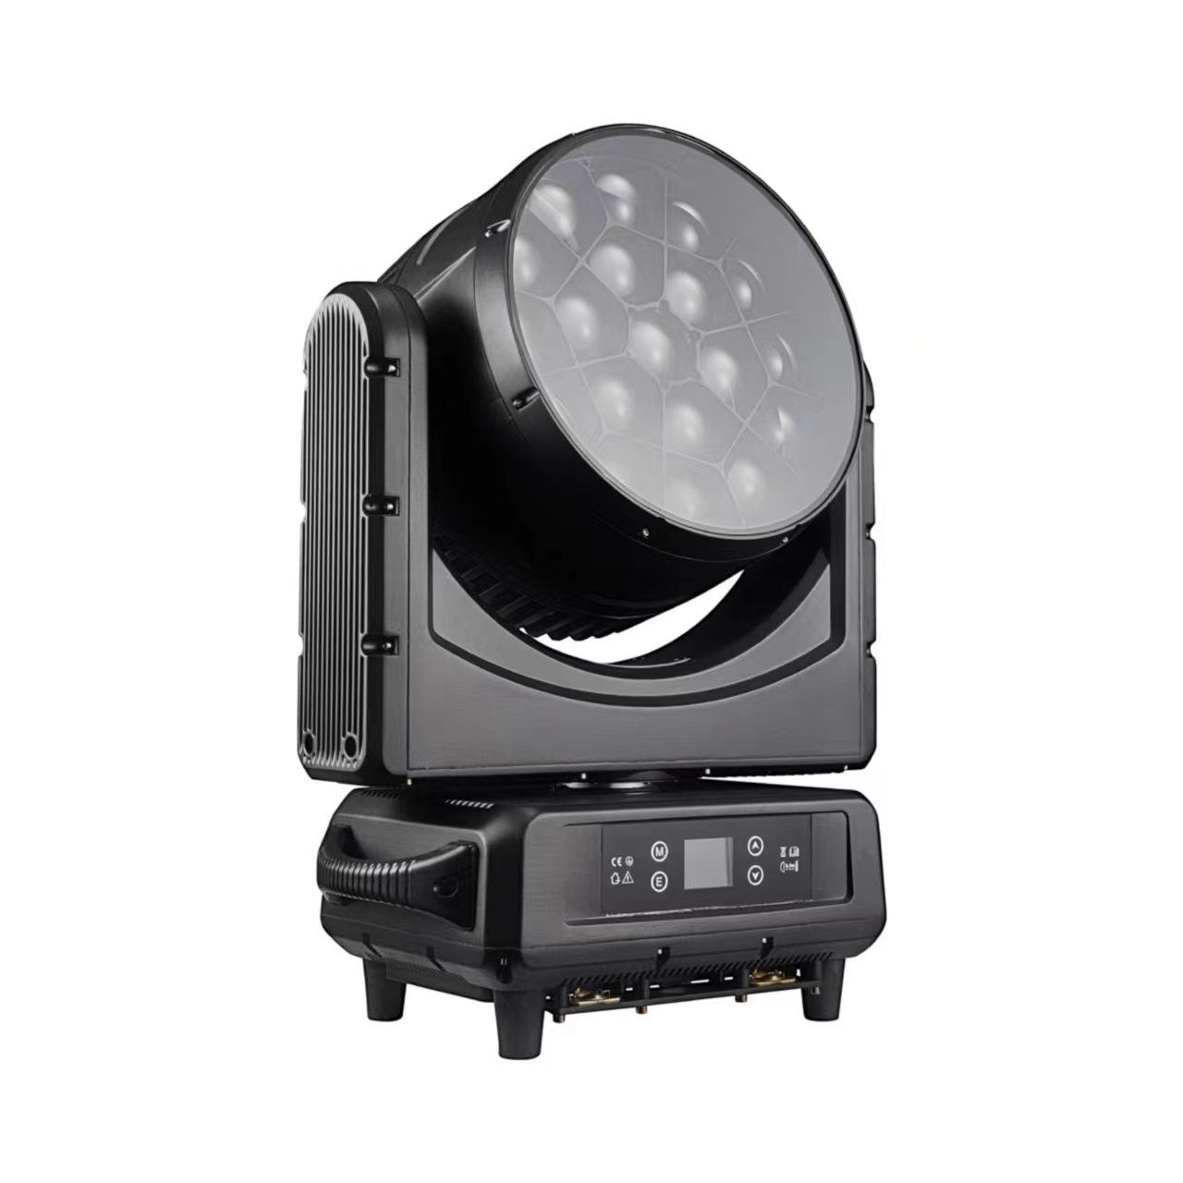

19X40 B-EYE
Please read the instructions carefully before use

TABLE OF CONTENTS
1. Safety Instructions 3-4
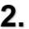
Technical Specifications four
Control Menu 5-6

DMX Channels 6-14
Trouble Shooting 15
Fixture Cleaning 15

STATEMENT
The product has well capability and intact packing when leave factory. All of the user should comply with warning item and manual, any misuse cause of the damages are not included in our guarantee, and also can not be responsible for any malfunction & problem owing to ignore the manual.

Safety Instructions

Please keep this User Guide for future consultation. If you sell the unit to another user, be sure that they also receive this instruction booklet.
- Unpack and check carefully there is no transportation damage before using the unit.
- Before operating, ensure that the voltage and frequency of power supply match the power requirements of the unit.
- It’s important to ground the yellow/green conductor to earth in order to avoid electric shock.
- The unit is for indoor use only. Use only in a dry location.
- The unit must be installed in a location with adequate ventilation, at least 50cm from adjacent surfaces. Be sure that no ventilation slots are blocked.
- Disconnect main power before replacement or servicing.
- Make sure there are no flammable materials close to the unit while operating as it is fire hazard.
- Use safety cable when fixes this unit. DO NOT handle the unit by taking its head only, but always by taking its base.
- Maximum ambient temperature is Ta: 40℃. DO NOT operate it where the temperature is higher
than this Unit surface temperature may reach up to 85℃. DO NOT touch the housing bare-hand during its operation. Turn off the power and allow about 15 minutes for the unit to cool down before replacing or serving.
- the event of serious operating problem, stop using the unit immediately.Never try to repair the unit by yourself. Repairs carried out by unskilled people can lead to damage or malfunction. P lease contact the nearest authorized technical assistance center. Always use the same type spare parts.
- DO NOT touch any wire during operation as high voltage might be causing electric shock.
Warning:
- To prevent or reduce the risk of electrical shock or fire, do not expose the unit to rain or moisture.
- The housing, the lenses, or the ultraviolet filter must be replaced if they are visibly damaged.
Caution:
- There are no user serviceable parts inside the unit. DO NOT open the housing or attempt any repairs yourself. In the unlikely event your unit may require service, please contact your nearest dealer.
Installation:
- The unit should be mounted via its screw holes on the bracket. Always ensure that the unit is firmly

fixed to avoid vibration and slipping while operating. And make sure that the structure to which you are attaching the unit is secure and is able to su pport a weight of 10 times of the unit’s weight. Also always use a safety cable that can hold 12 times of the weight of the unit when installing the fixture.
- The equipment must be fixed by professionals. And it must be fixed at a place where is out of the
touch of people.

Technical Specifications

Voltage: AC100V～240V 50-60HZ

Rated Power: 760W

LED Source: 19x40W high power RGBW 4 in 1 LEDs Zoom: 4°-60°
Strobe: 0-20Hz

Control Mode: DMX512,Sound-actived,Master/slave DMX Channels: 21/23/35/78/92/97/99 channel Dimmer: 0-100% linear dimmer
Pan: 540°+16 bit fine Tilt: 270°+16 bit fine
Display: LCD colorful display Rechargeable Battery: Optional IP: IP20

Control Menu

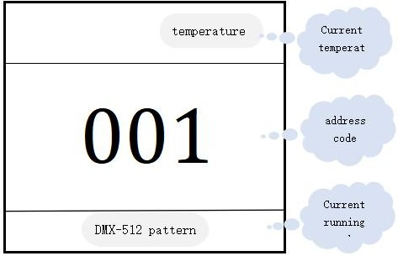
Menu Operation
Address: Click to enter the address code setting Settings: Click to enter system settings
Test: Click to enter manual mode
Calibration: Click to enter the password to enter the system calibration mode Reset: Click to enter the system reset mode
Information: Click to enter to view system information

menu | Sublevel menu | Three menu / parameters | Fourth
address | 001 - 512
Fixture | Dmx Mode | STD / HSI
Fixture | Run Mode | DMX / Host / Sound
Fixture | Pan Invert | Close / Open
Fixture | Tilt Invert | Close / Open
Fixture | Fan Control | Auto/Client
Manual | Pan | 000-255
Manual | Pan Fine | 000-255
Manual | Tilt | 000-255
Manual | Tilt Fine | 000-255
Manual | ⁞ | ⁞
Information | Time | Current Time | xxxH
Information | Time | Current Time | xxxH
Information | Sensor | Pan | FALSE / TURE
Information | Sensor | Tilt | FALSE / TURE
Information | Sensor | Zoom | FALSE / TURE
Information | Sensor | Temp | FALSE / TURE
Information | Sensor | Fan | FALSE / TURE
Information | Temperature | Head Temp | xxxC

Information | Software Version | Panel | Vx.xx
Information | Software Version | Motor | Vx.xx
Information | Software Version | Dimmer1 | Vx.xx
Information | Software Version | Dimmer2 | Vx.xx
Factory | Password | 000 - 255
Factory | Pan | 000 - 255
Factory | Tilt | 000 - 255
Factory | Zoom | 000 - 255
Factory | Zoom Rotation | 000 - 255
Factory | Red | 000 - 255
Factory | Green | 000 - 255
Factory | Blue | 000 - 255
Factory | White | 000 - 255
Fixture Reset | Motor Reset | Cance / Run
Fixture Reset | Factory | Cance / Run
Display | Language | CH / EN
Display | Display Flip | Normal / Reverse
Display | Display Mode | 60s / Show

DMX Channels

21 channel

ch | function | DMX value | detailed information
1 | red | 0-255 | Red 0-100% brightness adjustment, from dark to bright.
2 | Red fine tuning | 0-255 | Red fine tuning
3 | green | 0-255 | Green 0-100% brightness adjustment, from dark to bright.
4 | Green fine tuning | 0-255 | Green fine tuning
5 | blue | 0-255 | Blue 0-100% brightness adjustment, from dark to bright.
6 | Blue fine tuning | 0-255 | Blue fine tuning
7 | white | 0-255 | White 0-100% brightness adjustment, from dark to bright.
8 | White fine tuning | 0-255 | White fine tuning
9 | colour temperature | 0-255 | Linear control of color temperature
10 | Macro color | 0-255 | Macro change of color
11 | stroboscopic | 0-3 | Lights go out
11 | stroboscopic | 4-103 | Use the same steps from slow to fast.
11 | stroboscopic | 104-107 | Light up
11 | stroboscopic | 108-207 | Strongpoint from slow to fast.
11 | stroboscopic | 208-212 | Light up
11 | stroboscopic | 213-225 | Low speed random strobe
11 | stroboscopic | 226-238 | Medium speed random strobe
11 | stroboscopic | 239-251 | High speed random strobe
11 | stroboscopic | 252-255 | Light up
12 | light modulator | 0-255 | 0-100 Linear brightness adjustment
13 | Fine adjustment of dimmer | 0-255 | Fine adjustment of dimmer
14 | X axis control | 0-255 | X axis control
15 | X-axis fine tuning | 0-255 | X-axis fine tuning
16 | Y axis control | 0-255 | Y axis control
17 | Y axis fine tuning | 0-255 | Y axis fine tuning
18 | function | 0-255 | Empty (no function)
19 | reset | 0-250 | No function
19 | reset | 251-255 | Wait 5 seconds for automatic reset.
20 | focus | 0-255 | Focusing control
21 | rotate | 0-127 | 0 to 60 degrees
21 | rotate | 128-191 | Rotate clockwise from fast to slow
21 | rotate | 192-255 | Rotate counterclockwise from slow to fast
23 channel

ch | function | DMX value | detailed information
1 | X axis control | 0-255 | X axis control
2 | X-axis fine tuning | 0-255 | X-axis fine tuning
3 | Y axis control | 0-255 | Y axis control
4 | Y axis fine tuning | 0-255 | Y axis fine tuning
5 | XY axis velocity | 0-255 | Speed from slow to fast
6 | focus | 0-255 | Focusing control
7 | rotate | 0-127 | 0 to 60 degrees
7 | rotate | 128-191 | Rotate clockwise from slow to fast
7 | rotate | 192-255 | Rotate counterclockwise from slow to fast
8 | light modulator | 0-255 | 0-100% linear brightness adjustment
9 | stroboscopic | 0-3 | light ...
9 | stroboscopic | 4-200 | Use the same steps from slow to fast.
9 | stroboscopic | 201-255 | Random spectrum slow
10 | red | 0-255 | Red 0-100% brightness adjustment, from dark to bright.
11 | green | 0-255 | Red 0-100% brightness adjustment, from dark to bright.
12 | green | 0-255 | Red 0-100% brightness adjustment, from dark to bright.
13 | white | 0-255 | Red 0-100% brightness adjustment, from dark to bright.
14 | colour temperature | 0-255 | Linear color temperature control
15 | Color macro | 0-255 | Macro change of color
16 | Static effect | 0-255 | Every 5 DMX values are a static effect.
17 | Dynamic effect | 0-255 | The value of every 5 DMX is a dynamic effect.
18 | Dynamic effect speed | 0-255
19 | Background color red | 0-255 | 1-100% background red brightness adjustment, from dark to bright.
20 | Background color green | 0-255 | 1-100% background blue brightness adjustment, from dark to bright.
21 | Background color blue | 0-255 | 1-100% background green brightness adjustment, from dark to bright.
22 | Background color is white. | 0-255 | 1-100% background blue brightness adjustment, from dark to bright.
23 | reset | 0-250 | invalid
23 | reset | 251-255 | Wait 5 seconds for automatic reset.

35 channel

ch | function | Data multiplexer | detailed information
1 | red | 0-255 | Red 0-100% brightness adjustment, from dark to bright.
2 | Red fine tuning | 0-255 | Red fine tuning
3 | green | 0-255 | Green 0-100% brightness adjustment, from dark to bright.
4 | Green fine tuning | 0-255 | Green fine tuning
5 | blue | 0-255 | Blue 0-100% brightness adjustment, from dark to bright.
6 | Blue fine tuning | 0-255 | Blue fine tuning
7 | white | 0-255 | White 0-100% brightness adjustment, from dark to bright.
8 | White fine tuning | 0-255 | White fine tuning
9 | colour temperature | 0-255 | Linear control of color temperature
10 | Macro color | 0-255 | Macro change of color
11 | stroboscopic | 0-3 | Light up
11 | stroboscopic | 4-103 | Use the same steps from slow to fast.
11 | stroboscopic | 104-107 | Light up
11 | stroboscopic | 108-207 | Separating stroboscope from slow speed
11 | stroboscopic | 208-212 | Light up
11 | stroboscopic | 213-255 | Random flash
12 | light modulator | 0-255 | 0-100% linear brightness adjustment
13 | Fine adjustment of dimmer | 0-255 | Fine adjustment of dimmer
14 | X axis control | 0-255 | X axis control
15 | X-axis fine tuning | 0-255 | X-axis fine tuning
16 | Y axis control | 0-255 | Y axis control
17 | Y axis fine tuning | 0-255 | Y axis fine tuning
18 | function | 0-255 | Empty (no function)
19 | reset | 0-250 | No function
19 | reset | 251-255 | Wait 5 seconds for automatic reset.
20 | focus | 0-255 | Focusing control
21 | rotate | 0-127 | 0 to 60 degrees
21 | rotate | 128-191 | Rotate clockwise from fast to slow
21 | rotate | 192-255 | Rotate counterclockwise from slow to fast
22 | Shape selection | 0-255 | Choose a shape
23 | Shape velocity | 0-255 | Shape speed control
24 | Shape closure | 0-255 | Shape closure
25 | Shape r | 0-255 | Red shape
26 | Shape g | 0-255 | Green shape
27 | Shape b | 0-255 | Blue shape
28 | Shape w | 0-255 | White shape
29 | Shape brightness adjustment | 0-255 | Shape dimmer 0-100%
30 | Background brightness adjustment | 0-255 | Background dimmer 0-100%
31 | Shape change | 0-255 | Shape change
32 | Shape deviation | 0-255 | Shape deviation
33 | Foreground control | 0-255 | Foreground detector control
34 | Background color control | 0-255 | Background detector control
35 | Background selection | 0-255 | Background selection

78 channel

ch | function | Data multiplexer | detailed information
1 | red | 0-255 | Red 0-100% brightness adjustment, from dark to bright.
2 | Red fine tuning | 0-255 | Red fine tuning
3 | green | 0-255 | Green 0-100% brightness adjustment, from dark to bright.
4 | Green fine tuning | 0-255 | Green fine tuning
5 | blue | 0-255 | Blue 0-100% brightness adjustment, from dark to bright.
6 | Blue fine tuning | 0-255 | Blue fine tuning
7 | white | 0-255 | White 0-100% brightness adjustment, from dark to bright.
8 | White fine tuning | 0-255 | White fine tuning
9 | colour temperature | 0-255 | Linear control of color temperature
10 | Macro color | 0-255 | Macro change of color
11 | stroboscopic | 0-3 | light ...
11 | stroboscopic | 4-203 | Use the same steps from fast to slow.
11 | stroboscopic | 204-255 | Random stroboscopic
12 | light modulator | 0-255 | 0-100% linear brightness adjustment
13 | Fine adjustment of dimmer | 0-255 | Fine adjustment of dimmer
14 | X axis control | 0-255 | X axis control
15 | X-axis fine tuning | 0-255 | X-axis fine tuning
16 | Y axis control | 0-255 | Y axis control
17 | Y axis fine tuning | 0-255 | Y axis fine tuning
18 | function | 0-255 | Empty (no function)
19 | reset | 0-250 | No function
19 | reset | 251-255 | Wait 5 seconds for automatic reset.
20 | focus | 0-255 | Focusing control
21 | rotate | 0-127 | 0 to 60 degrees
21 | rotate | 128-191 | Rotate clockwise from fast to slow
21 | rotate | 192-255 | Rotate counterclockwise from slow to fast
22 | Red dimmer 1 | 0-255 | LED1 red dimmer
23 | Green dimmer 1 | 0-255 | LED1 green dimmer
24 | Blue dimmer 1 | 0-255 | LED1 blue dimmer
25 | Red dimmer 2 | 0-255 | LED2 red dimmer
26 | Green dimmer 2 | 0-255 | LED2 green dimmer
27 | Blue dimmer 2 | 0-255 | LED2 blue dimmer
…… | ……… | ……… | ………
… | ……… | ……… | ………
76 | Red dimmer 19 | 0-255 | LED19 red dimmer
77 | Green dimmer | 0-255 | LED19 green dimmer
78 | Blue dimmer 19 | 0-255 | LED19 blue dimmer

92-channel mode

ch | function | Data multiplexer | detailed information
1 | red | 0-255 | Red 0-100% brightness adjustment, from dark to bright.
2 | Red fine tuning | 0-255 | Red fine tuning
3 | green | 0-255 | Green 0-100% brightness adjustment, from dark to bright.
4 | Green fine tuning | 0-255 | Green fine tuning
5 | blue | 0-255 | Blue 0-100% brightness adjustment, from dark to bright.
6 | Blue fine tuning | 0-255 | Blue fine tuning
7 | white | 0-255 | White 0-100% brightness adjustment, from dark to bright.
8 | White fine tuning | 0-255 | White fine tuning
9 | colour temperature | 0-255 | Linear control of color temperature
10 | Macro color | 0-255 | Macro change of color
11 | stroboscopic | 0-3 | Light up
11 | stroboscopic | 4-103 | Use the same steps from slow to fast.
11 | stroboscopic | 104-107 | Light up
11 | stroboscopic | 108-207 | Separating stroboscope from slow speed
11 | stroboscopic | 208-212 | Light up
11 | stroboscopic | 213-251 | Random strongpoint from slow speed
11 | stroboscopic | 252-255 | Light up
12 | light modulator | 0-255 | 0-100% linear brightness adjustment
13 | Fine adjustment of dimmer | 0-255 | Fine adjustment of dimmer
14 | X axis control | 0-255 | X axis control
15 | X-axis fine tuning | 0-255 | X-axis fine tuning
16 | Y axis control | 0-255 | Y axis control
17 | Y axis fine tuning | 0-255 | Y axis fine tuning
18 | function | 0-255 | Empty (no function)
19 | reset | 0-250 | No function
19 | reset | 251-255 | Wait 5 seconds for automatic reset.
20 | focus | 0-255 | Focusing control
21 | rotate | 0-127 | 0 to 60 degrees
21 | rotate | 128-191 | Rotate clockwise from fast to slow
21 | rotate | 192-255 | Rotate counterclockwise from slow to fast
22 | Shape selection | 0-255 | Choose a shape
23 | Shape velocity | 0-255 | Shape speed control
24 | Shape disappearance | 0-255 | Shape closure
25 | Shape r | 0-255 | Red shape
26 | Shape g | 0-255 | Green shape
27 | Shape b | 0-255 | Blue shape
28 | Shape w | 0-255 | White shape
29 | Shape brightness adjustment | 0-255 | Shape dimmer 0-100%
30 | Background brightness adjustment | 0-255 | Background dimmer 0-100%
31 | Shape transformation | 0-255 | Shape change
32 | Shape deviation | 0-255 | Shape deviation
33 | Foreground control | 0-255 | Foreground detector control
34 | Background color control | 0-255 | Background detector control
35 | Background selection | 0-255 | Background selection
36 | Red dimmer 1 | 0-255 | LED1 red dimmer
37 | Green dimmer 1 | 0-255 | LED1 green dimmer
38 | Blue dimmer 1 | 0-255 | LED1 blue dimmer
39 | Red dimmer 2 | 0-255 | LED2 red dimmer
40 | Green dimmer 2 | 0-255 | LED2 green dimmer
41 | Blue dimmer 2 | 0-255 | LED2 blue dimmer
…… | ……… | ……… | ………
… | ……… | ……… | ………
90 | Red dimmer 19 | 0-255 | LED19 red dimmer
91 | Green dimmer 19 | 0-255 | LED19 green dimmer
92 | Blue dimmer 19 | 0-255 | LED19 blue dimmer

97 channels

ch | function | DMX value | detailed information
1 | red | 0-255 | Red 0-100% brightness adjustment, from dark to bright.
2 | Red fine tuning | 0-255 | Red fine tuning
3 | green | 0-255 | Green 0-100% brightness adjustment, from dark to bright.
4 | Green fine tuning | 0-255 | Green fine tuning
5 | blue | 0-255 | Blue 0-100% brightness adjustment, from dark to bright.
6 | Blue fine tuning | 0-255 | Blue fine tuning
7 | white | 0-255 | White 0-100% brightness adjustment, from dark to bright.
8 | White fine tuning | 0-255 | White fine tuning
9 | colour temperature | 0-255 | Linear control of color temperature
10 | Macro color | 0-255 | Macro change of color
11 | stroboscopic | 0-3 | Lights go out
11 | stroboscopic | 4-203 | Use the same steps from slow to fast.
11 | stroboscopic | 204-255 | Langdon strobe
12 | light modulator | 0-255 | 0-100% linear brightness adjustment
13 | Fine adjustment of dimmer | 0-255 | Fine adjustment of dimmer
14 | X axis control | 0-255 | X axis control
15 | X-axis fine tuning | 0-255 | X-axis fine tuning
16 | Y axis control | 0-255 | Y axis control
17 | Y axis fine tuning | 0-255 | Y axis fine tuning
18 | function | 0-255 | Empty (no function)
19 | reset | 0-250 | No function
19 | reset | 251-255 | Wait 5 seconds for automatic reset.
20 | focus | 0-255 | Focusing control
21 | rotate | 0-127 | 0 to 60 degrees
21 | rotate | 128-191 | Rotate clockwise from slow to fast
21 | rotate | 192-255 | Rotate counterclockwise from slow to fast
22 | Red dimmer 1 | 0-255 | LED1 red dimmer
23 | Green dimmer 1 | 0-255 | LED1 green dimmer
24 | Blue dimmer 1 | 0-255 | LED1 blue dimmer
25 | White dimmer 1 | 0-255 | LED1 white dimmer
…… | ……… | ……… | ………
… | ……… | ……… | ………
94 | Red dimmer 19 | 0-255 | LED19 red dimmer
95 | Green dimmer 19 | 0-255 | LED19 green dimmer
96 | Blue dimmer 19 | 0-255 | LED19 blue dimmer
97 | White dimmer 19 | 0-255 | LED19 white dimmer

Channel 99

ch | function | DMX value | detailed information
1 | X axis control | 0-255 | X axis control
2 | X-axis fine tuning | 0-255 | X-axis fine tuning
3 | Y axis control | 0-255 | Y axis control
4 | Y axis fine tuning | 0-255 | Y axis fine tuning
5 | XY axis velocity | 0-255 | Speed from slow to fast
6 | focus | 0-255 | Focusing control
7 | rotate | 0-127 | 0 to 60 degrees
7 | rotate | 128-191 | Rotate clockwise from slow to fast
7 | rotate | 192-255 | Rotate counterclockwise from slow to fast
8 | light modulator | 0-255 | 0-100% linear hidden weapons modulation
9 | stroboscopic | 0-3 | light ...
9 | stroboscopic | 4-200 | Use the same steps from slow to fast.
9 | stroboscopic | 201-255 | Random spectrum slow
10 | red | 0-255 | Red 0-100% brightness adjustment, from dark to bright.
11 | green | 0-255 | green 0-100% brightness adjustment, from dark to bright.
12 | blue | 0-255 | blue 0-100% brightness adjustment, from dark to bright.
13 | white | 0-255 | white 0-100% brightness adjustment, from dark to bright.
14 | colour temperature | 0-255 | Linear color temperature control
15 | Color macro | 0-255 | Macro change of color
16 | Static effect | 0-255 | Every 5 DMX values are a static effect.
17 | Dynamic effect | 0-255 | The value of every 5 DMX is a dynamic effect.
18 | Dynamic effect speed | 0-255
19 | Background color red | 0-255 | 1-100% background red brightness adjustment, from dark to bright.
20 | Background color green | 0-255 | 1-100% background blue brightness adjustment, from dark to bright.
21 | Background color blue | 0-255 | 1-100% background green brightness adjustment, from dark to bright.
22 | Background color is white. | 0-255 | 1-100% background blue brightness adjustment, from dark to bright.
23 | reset | 0-250 | No function
23 | reset | 251-255 | The reset time is 5 seconds.
24 | Red dimmer 1 | 0-255 | LED1 red dimmer
25 | Green dimmer 1 | 0-255 | LED1 green dimmer
26 | Blue dimmer 1 | 0-255 | LED1 blue dimmer
27 | White dimmer 1 | 0-255 | LED1 white dimmer
…… | ……… | ……… | ………
… | ……… | ……… | ………
96 | Red dimmer 19 | 0-255 | LED19 red dimmer
97 | Green dimmer 19 | 0-255 | LED19 green dimmer
98 | Blue dimmer 19 | 0-255 | LED19 blue dimmer
99 | White dimmer 19 | 0-255 | LED19 white dimmer

Trouble Shooting
Following are a few common problems that may occur during operation. Here are some suggestions for easy troubleshooting:

  - The unit does not work, no light and the fan does not work
    - Check the connection of power and main fuse.
    - Measure the mains voltage on the main connector.
    - Check the power on LED.

  - Not responding to DMX controller
    - DMX LED should be on. If not, check DMX connectors, cables to see if link properly.
    - If the DMX LED is on and no response to the channel, check the address settings and DMX polarity.
    - If you have intermittent DMX signal problems, check the pins on connectors or on PCB of the unit or the previous one.
    - Try to use another DMX controller.
    - Check if the DMX cables run near or run alongside to high voltage cables that may cause damage or interference to DMX interface circuit.
  - One of the channels is not working well
    - The stepper motor might be damaged or the cable connected to the PCB is broken.
    - The motor’s drive IC on the PCB might be out of condition

7.Fixture Cleaning
The cleaning of internal and external optical lenses and/ or mirrors must be carried out periodically to optimize light output. Cleaning frequency depends on the environment in which the fixture operates: damp , smoky or particularly dirty surrounding can cause greater accumulation of dirt on the unit’s optics.
Clean with soft cloth using normal glass cleaning fluid. Always dry the parts carefully.
Clean the external optics at least every 20 days. Clean the internal optics at least every 30/60 days.

