USER MANUAL



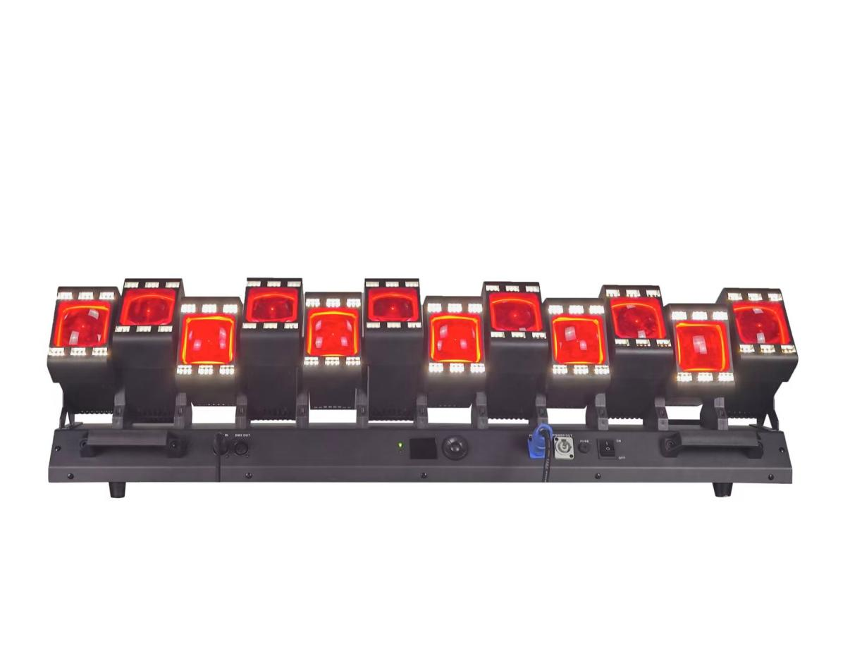
Instructions for Use of 12 Avalokitesvara with Thousand Hands

Product technical parameters:
Electrical voltage: AC90-240V.
Work rate: 800w
Frequency: 50-60Hz
Lamp beads: 12 40W 4-in-1LED lamp beads with auxiliary light of 12*6*2W yellow and white.
Access: 19CH/41CH /85CH
Control mode: DMX512/ Master/Slave/Voice Control/Self-propelled
Horizontal scanning: 540 degrees and vertical scanning: 270 degrees.
Frequency flash: 1-25 times/second or random.
Dimming: 0-100% linear dimming
Features: single independent swing, light beam, dyeing, auxiliary light
Appearance: metal, black
Display screen: Chinese/English WQERFWSFRF
Grade I: IP20
Net weight: 23KG
Foot inch: 1020*145*268MM

Channel 19 | Channel value | fundamental function
one | 000-255 | Y1-Y12 axis 0~270 degrees
2 | 000-255 | Y1-Y12 Fine adjustment (Y mode amplitude)
three | 000-255 | Y speed (y mode speed)
four | 000-255 | Y mode (Y effect range)
five | 000-255 | Total dimming
six | 000-255 | Main lamp stroboscopic
seven | 000-255 | Main lamp color selection
eight | 000-255 | Main lamp built-in effect
nine | 000-255 | Main lamp built-in effect speed
10 | 000-255 | Main light red (effect color selection)
11 | 000-255 | Main light green (color selection for effect)
twelve | 000-255 | Main light blue (effect color selection)
13 | 000-255 | Main light white (effect color selection)
14 | 000-255 | Color selection of light strip
15 | 000-255 | Built-in effect of light strip
16 | 000-255 | Built-in effect speed of light strip
17 | 000-255 | Light with white (effect color selection)
18 | 000-255 | The light is yellow (effect color selection)
19 | 000-255 | reset
Channel 41 | Channel value | fundamental function
one | 000-255 | Y1 axis 0~270 degrees
2 | 000-255 | Y1 fine tuning
three | 000-255 | Y2 axis 0~270 degrees
four | 000-255 | Y2 fine tuning
five | 000-255 | Y3 axis 0~270 degrees
six | 000-255 | Y3 fine tuning
seven | 000-255 | Y4 axis 0~270 degrees
eight | 000-255 | Y4 fine tuning
nine | 000-255 | Y5 axis 0~270 degrees
10 | 000-255 | Y5 fine tuning
11 | 000-255 | Y6 axis 0~270 degrees
twelve | 000-255 | Y6 fine tuning
13 | 000-255 | Y7 axis 0~270 degrees
14 | 000-255 | Y7 fine tuning
15 | 000-255 | Y8 axis 0~270 degrees
16 | 000-255 | Y8 fine tuning
17 | 000-255 | Y9 axis 0~270 degrees
18 | 000-255 | Y9 fine tuning
19 | 000-255 | Y10 axis 0~270 degrees
twenty | 000-255 | Y10 fine tuning
21 | 000-255 | Y11 axis 0~270 degrees
22 | 000-255 | Y11 fine tuning
23 | 000-255 | Y12 axis 0~270 degrees
24 | 000-255 | Y12 fine tuning
25 | 000-255 | Y speed (y mode speed)
26 | 000-255 | Y mode (Y effect range)
27 | 000-255 | Total dimming
28 | 000-255 | Main lamp stroboscopic
29 | 000-255 | Main lamp color selection
thirty | 000-255 | Main lamp built-in effect
31 | 000-255 | Main lamp built-in effect speed
32 | 000-255 | Main light red (effect color selection)
33 | 000-255 | Main light green (color selection for effect)
34 | 000-255 | Main light blue (effect color selection)
35 | 000-255 | Main light white (effect color selection)
36 | 000-255 | Color selection of light strip
37 | 000-255 | Built-in effect of light strip
38 | 000-255 | Built-in effect speed of light strip
39 | 000-255 | Light with white (effect color selection)
40 | 000-255 | The light is yellow (effect color selection)
41 | 000-255 | reset
Channel 85 | Channel value | fundamental function
one | 000-255 | Y1 axis 0~270 degrees
2 | 000-255 | Y1 fine tuning
three | 000-255 | Y2 axis 0~270 degrees
four | 000-255 | Y2 fine tuning
five | 000-255 | Y3 axis 0~270 degrees
six | 000-255 | Y3 fine tuning
seven | 000-255 | Y4 axis 0~270 degrees
eight | 000-255 | Y4 fine tuning
nine | 000-255 | Y5 axis 0~270 degrees
10 | 000-255 | Y5 fine tuning
11 | 000-255 | Y6 axis 0~270 degrees
twelve | 000-255 | Y6 fine tuning
13 | 000-255 | Y7 axis 0~270 degrees
14 | 000-255 | Y7 fine tuning
15 | 000-255 | Y8 axis 0~270 degrees
16 | 000-255 | Y8 fine tuning
17 | 000-255 | Y9 axis 0~270 degrees
18 | 000-255 | Y9 fine tuning
19 | 000-255 | Y10 axis 0~270 degrees
twenty | 000-255 | Y10 fine tuning
21 | 000-255 | Y11 axis 0~270 degrees
22 | 000-255 | Y11 fine tuning
23 | 000-255 | Y12 axis 0~270 degrees
24 | 000-255 | Y12 fine tuning
25 | 000-255 | Y speed (y mode speed)
26 | 000-255 | Y mode (Y effect range)
27 | 000-255 | Total dimming
28 | 000-255 | Main lamp stroboscopic
29 | 000-255 | Main lamp color selection
thirty | 000-255 | Main lamp built-in effect
31 | 000-255 | Main lamp built-in effect speed
32 | 000-255 | Main light 1 red dimming
33 | 000-255 | Main light 1 green dimming
34 | 000-255 | Main light 1 blue dimming
35 | 000-255 | Main light 1 white dimming
36 | 000-255 | Main light 2 red dimming
37 | 000-255 | Main light 2 green dimming
38 | 000-255 | Main light 2 blue dimming
39 | 000-255 | Main lamp 2 white dimming
40 | 000-255 | Main light 3 red dimming
41 | 000-255 | Main light 3 green dimming
forty-two | 000-255 | Main light 3 blue dimming
43 | 000-255 | Main light 3 white dimming
forty-four | 000-255 | Main light 4 red dimming
45 | 000-255 | Main light 4 green dimming
46 | 000-255 | Main light 4 blue dimming
47 | 000-255 | Main light 4 white dimming
48 | 000-255 | Main light 5 red dimming
forty-nine | 000-255 | Main light 5 green dimming
50 | 000-255 | Main light 5 blue dimming
51 | 000-255 | Main light 5 white dimming
fifty-two | 000-255 | Main light 6 red dimming
53 | 000-255 | Main light 6 green dimming
54 | 000-255 | Main light 6 blue dimming
55 | 000-255 | Main light 6 white dimming
fifty-six | 000-255 | Main light 7 red dimming
57 | 000-255 | Main light 7 green dimming
58 | 000-255 | Main light 7 blue dimming
59 | 000-255 | Main light 7 white dimming
60 | 000-255 | Main light 8 red dimming
61 | 000-255 | Main light 8 green dimming
62 | 000-255 | Main light 8 blue dimming
63 | 000-255 | Main light 8 white dimming
64 | 000-255 | Main light 9 red dimming
65 | 000-255 | Main light 9 green dimming
66 | 000-255 | Main light 9 blue dimming
67 | 000-255 | Main light 9 white dimming
sixty-eight | 000-255 | The main light 10 is dimmed in red.
sixty-nine | 000-255 | Green dimming of main light 10
70 | 000-255 | Blue dimming of main light 10
71 | 000-255 | White dimming of main lamp 10
seventy-two | 000-255 | Main light 11 is dimmed in red.
73 | 000-255 | Green dimming of main light 11
74 | 000-255 | Blue dimming of main light 11
75 | 000-255 | Main light 11 white dimming
76 | 000-255 | The main light 12 is dimmed in red.
77 | 000-255 | The main light 12 is dimmed green.
seventy-eight | 000-255 | The main light 12 is dimmed blue.
79 | 000-255 | White dimming of main lamp 12
80 | 000-255 | Color selection of light strip
81 | 000-255 | Built-in effect of light strip
82 | 000-255 | Built-in effect speed of light strip
83 | 000-255 | Light with white (effect color selection)
84 | 000-255 | The light is yellow (effect color selection)
eighty-five | 000-255 | reset

Cleaning and maintenance
The equipment requires daily cleaning and maintenance. The service life of the equipment depends largely on the operating environment and daily cleaning and maintenance. Before opening any cover, cut off the power supply.
Optical components should be lightly rubbed, and the coating surface is brittle and easy to scratch. Do not use destructive solvents or it will damage the plastic or coating surface. Use a soft brush, cotton paper, air cleaner or pressure blower to remove dust from fans and air holes.

warning message
